Note: I have written comments on each exam, sometimes referencing what’s in this memo and sometimes with other specific comments. I graded the electronic versions, so if you want the comments, please send me your exam number and I will email you the graded version.

- Pirate Party (10 points)

Encrypting a wireless router is simple and prevents unauthorized users from using the router for any internet access whatsoever. Unencrypted access can make it impossible to determine who downloaded infringing material. The Pirate Party, a coffee shop right next to the campus of Unseen University, operates an unencrypted wireless router. It advertises the availability of “free, no-hassle wireless with your cup of joe—stay as long as you like.” Industry estimates are that over 50% of unauthorized downloads of music and movies are initiated by college students. The MPAA sues the Pirate Party, identifying over one hundred registered movies that have been downloaded without authorization over the PP’s wireless connection. What are the MPAA’s copyright theories, and should it win?

Direct liability: unlikely, given PP’s solely mechanical involvement in the copying, per Netcom.
Vicarious infringement: points given based on discussion of right and ability to control, plus direct financial benefit and the “draw” theory. Useful to distinguish between the draw of unencrypted wireless and the draw of infringement—there are other reasons to avoid the “hassle” of logging on than to infringe.
Contributory infringement: knowledge (or constructive knowledge) and substantial contribution or inducement. General knowledge that infringement is going on somewhere on the system probably isn’t enough to meet the knowledge requirement (though the name “the Pirate Party” indicates some potential bad faith and a possible inducement argument), but provision of the facilities for infringement probably is enough for substantial contribution under the precedents.

DMCA 512(a): there are different requirements for different subsections. Many of you thought that PP needed a registered agent/compliance with notice and takedown to take advantage of the safe harbor, which is true for ISPs seeking protection under 512(c) and 512(d) but not 512(a). Here’s 512(a) in its entirety:
(a) Transitory Digital Network Communications. — A service provider shall not be liable for monetary relief … for infringement of copyright by reason of the provider's transmitting, routing, or providing connections for, material through a system or network controlled or operated by or for the service provider, or by reason of the intermediate and transient storage of that material in the course of such transmitting, routing, or providing connections, if —
(1) the transmission of the material was initiated by or at the direction of a person other than the service provider;
(2) the transmission, routing, provision of connections, or storage is carried out through an automatic technical process without selection of the material by the service provider;
(3) the service provider does not select the recipients of the material except as an automatic response to the request of another person;
(4) no copy of the material made by the service provider in the course of such intermediate or transient storage is maintained on the system or network in a manner ordinarily accessible to anyone other than anticipated recipients, and no such copy is maintained on the system or network in a manner ordinarily accessible to such anticipated recipients for a longer period than is reasonably necessary for the transmission, routing, or provision of connections; and
(5) the material is transmitted through the system or network without modification of its content.

In addition, all safe harbors require compliance with 512(i), which require the existence of a repeat infringer policy and noninterference with technical measures used by copyright owners. On these facts, PP doesn’t have a repeat infringer policy “that provides for the termination in appropriate circumstances of subscribers and account holders of the service provider's system or network who are repeat infringers,” which would keep it out of the safe harbor, but would not affect its other defenses on secondary liability. §512(l). (One could argue that users who don’t log on aren’t subscribers or account holders, and thus PP has no subscribers or account holders and therefore isn’t required to follow this part of the definition; compare the class discussion of Google’s search services, which also doesn’t have subscribers or account holders in itself.)

- Improvisational Poetry (15 points)

Lacey Thornfield is a spoken-word artist who performs improvisational poetry. At an Art Crawl event, Lacey composes and recites a poem so powerful it makes many in the audience weep. Unbeknownst to Lacey, her landlord’s son, Pip, records her performance of the poem with his cellphone camera. Later, Lacey writes down the poem exactly as she recited it and publishes it in her book, Pillow Lips, which is properly registered. Pip then posts his recording on YouTube, where it receives over a million hits. As a participant in YouTube’s Partner Program, Pip receives a share of the advertising revenues from advertising displayed with the recording. Lacey sues Pip for copyright infringement. Identify the parties’ arguments about the rights at issue and explain who should win.

Fixation was the key to this question.

Lacey’s poem is unfixed (under the authority of the author) when Pip records it, and thus Lacey has no federal copyright claim at that time. When she later fixes it, the question is whether Pip’s copy of the unfixed work infringes the copyright in the fixed work, even though he copied the unfixed work (unprotected by federal law) and not the fixed work. Since the substance of the two is the same, there’s a good argument that Pip infringes the federal copyright, but the matter isn’t free from doubt. Pip copied the uncopyrighted performance, not the copyrighted work, but the metaphysics here are probably less important than the equities. The easiest argument here is the public performance right (which Pip is either directly responsible for with his YT partnership or secondarily liable for), since Pip’s initial reproduction comes before fixation and therefore doesn’t infringe, but his public posting comes after. (You could try distribution, subject to the difficulties of online “distribution” we discussed in class.) (Lacey also has a common-law copyright in the unfixed work, which she may assert under state law, but once the work is fixed federal copyright attaches and preempts any state common-law copyright claim.)

The antibootlegging statute doesn’t apply because Lacey isn’t engaged in a musical performance. Some of you tried to argue that spoken word poetry should count, but the statute is specifically limited and Congress knows how to cover all performance if it wants to; still, there were some good tries!.

Some people mentioned innocent infringers. This isn’t a defense (though it can lead to lower statutory damages in certain cases) unless the infringer relied on an authorized copy from which the pre-1989 required notice was omitted, 17 U.S.C. §405, which isn’t present here.

Those of you who analyzed Pip’s potential fair use defense tended to agree, correctly, that he didn’t have much of one.

- Peeps (35 points)

Every year, the Washington Post runs a Peeps diorama contest. Pictures of the best dioramas made with Peeps brand sugar candies are featured in a special photo section in the print edition and online. None of the participants are paid, though winners’ names are published. This year, one of the winning entries was The Very Hungry Caterpeeper, submitted by Aria Montgomery:
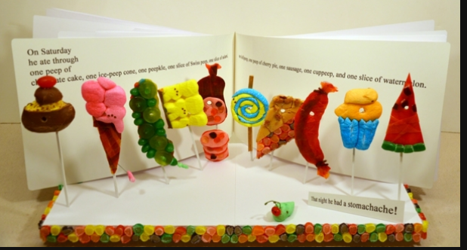
This year, the Post is also selling a Peeps calendar featuring twelve winning entries, including The Very Hungry Caterpeeper.

This diorama is based on a page from Eric Carle’s best-selling children’s book, The Very Hungry Caterpillar.

Front cover:
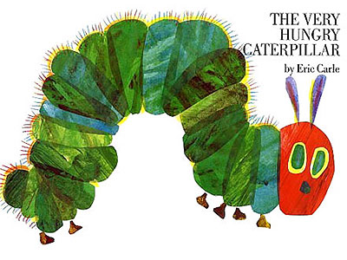
Middle page:
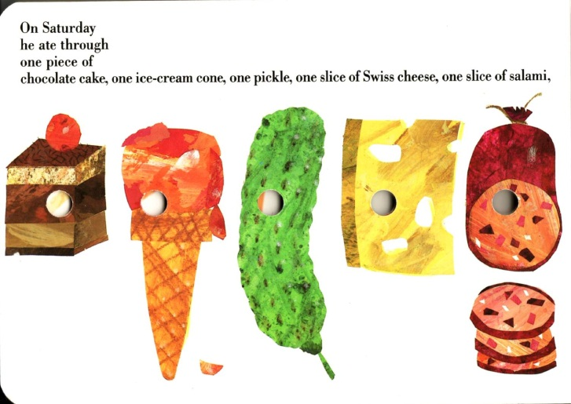
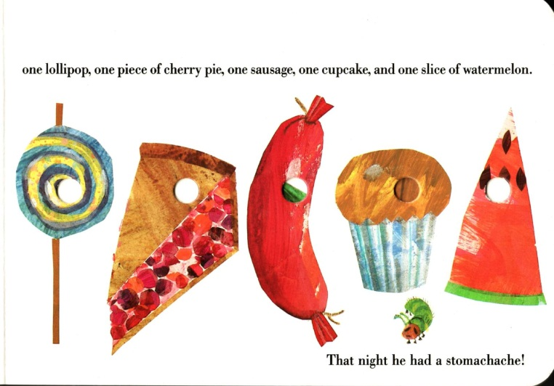

Instead of the text “On Saturday he ate through one piece of chocolate cake, one ice-cream cone, one pickle, one slice of Swiss cheese, one slice of salami, one lollipop, one piece of cherry pie, one sausage, one cupcake, and one slice of watermelon. That night he had a stomachache!” the Peeps version says “On Saturday he ate through one peep of chocolate cake, one ice-peep cone, one peepkle, one slice of Swiss peep, one slice of salami, one lollipeep, one peep of cherry pie, one sausage, one cuppeep, and one slice of watermelon. That night he had a stomachache!”

Carle has authorized numerous versions of the book, as well as other licensed merchandise, including clothing printed with images from the book, stuffed toy caterpillars, party plates and cups, puzzles, and umbrellas:
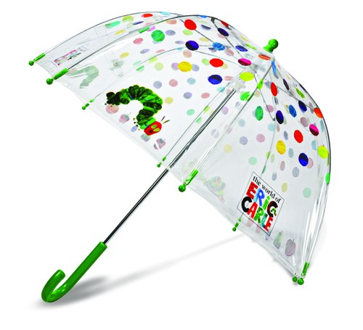
Carle has a copyright registration for The Very Hungry Caterpillar. Because of concerns for his artistic integrity, Carle does not allow alterations of the image of the caterpillar or other elements of the book, though he has authorized stuffed versions:

Stuffed version 1:
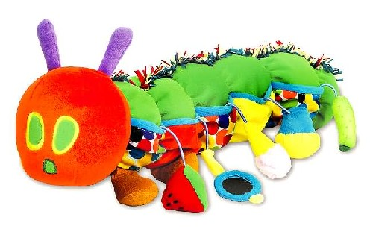
Stuffed version 2:
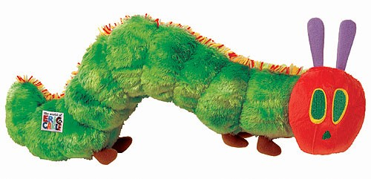
Carle has refused requests to license his work for use in sponsored products such as McDonald’s Happy Meals. He has stated that “to corporatize my work and tie it to someone else’s product would be to betray children.”

- (20 points) Carle sues Montgomery and The Washington Post for copyright infringement. Set out and evaluate his claims against Montgomery and against the Post and state who should win.

Good answers discussed reproduction/derivative works rights (Montgomery violated one or the other, absent an available defense) and fair use. Note that just because Carle didn’t enter the diorama market doesn’t necessarily mean it’s not a legitimate derivative works market—that’s the Seinfeld case—but on the other hand dioramas aren’t exactly a burgeoning market in the first place, which may bear on fair use. Transformation: it was important to distinguish between a fair use transformative purpose—criticism, commentary, or the like—and simple change in the work, which might only create a derivative work (see the Seinfeld and the Harry Potter Lexicon cases). Montgomery’s fair use claim is stronger than the Post’s, because Montgomery’s use was noncommercial (though she did get her name in the paper). You could reasonably come out either way on fair use, though it was important to weigh commerciality against whatever degree of transformativeness you found in the Post’s case; Campbell is very clear that commerciality is not determinative when there’s transformation, because so many transformative works are made for profit.

In addition, it was important to recognize that the Post’s infringement was not contributory or vicarious but direct. The Post made (and distributed) its own copies: its copying was totally volitional and not within Montgomery’s control once she’d submitted, just as any publisher’s decision to publish leads to direct liability even if there’s an individual author with a contract standing behind the publisher. While one could argue about the Post’s inducement etc. of Montgomery’s submission, given the Post’s direct involvement in infringement it’s rather pointless to do so.

There is no statutory basis for a moral rights claim. VARA only covers limited edition works of art, not books and not mass market works.

- (10 points) Assume instead that Carle does not file a lawsuit. Montgomery submitted a picture she took of her diorama to the Post after clicking on a box that said “I understand that any pictures I submit may be printed in the paper and online. I agree to give the Washington Post an irrevocable, nonexclusive license to any copyright I hold in the diorama, for any use the Washington Post makes, across all forms of media now known or later invented and throughout the world.” When the Post chose her diorama, it used her photograph in the newspaper and the calendar. Montgomery obtains the necessary registration and sues the Post for copyright infringement based on the Post’s sales of the calendar. Evaluate her claim and state who should win.

For this question, it was important to recognize that two copyrights were at issue: the copyright in the diorama, and the copyright in the picture of the diorama. (If the diorama was infringing, then there would be trouble with both under Pickett v. Prince, but it’s still possible that there’d be a valid copyright in the photo which reflects choices of angle and lighting, etc., that may be protectable against third-party copying.) The license, which is very badly written, gives the Post rights to the diorama, but only suggests that there is a license to use Montgomery’s photo in the paper. By using the photo in the calendar, the Post far exceeded the scope of the license; it needed to take its own photo of the diorama to stay within the scope of the license. This is infringement, not just breach of contract, because the breach involves performing acts that would be infringement if unauthorized—just like making 200 copies when the license says 20 (infringing), as opposed to making only the licensed 20 copies but failing to include attribution to the copyright owner as required by the license (mere breach of contract).

First sale, which applies when a copy has been transferred, is not relevant, because the issue is the copyright, not the ownership of any particular copy. The Post made a whole bunch of its own copies, making first sale inapplicable.

- (5 points) Carle seeks a registration for the stuffed version 2, shown above. Should his registration be allowed?

The key here was whether there was anything original in this change of medium that was sufficient new expression to be copyrightable. The 3D costume case, ERG, was highly relevant. Some argued that, since Carle was the owner of the copyright in the book, the concern for blocking the copyright owner’s right to authorize derivative works in ERG didn’t apply, but there’s another interest at stake: when the book’s copyright expires, anyone will be able to make derivative works of it—except that if Carle [or his heir] has a copyright in the caterpillar toy, he may be able to threaten suit against competitors, as in Batlin. Some people noted that Carle might not have the right to register if he wasn’t the author of the creative material in the caterpillar; I gave partial credit for this. Full credit required analysis of whether the toy contained any copyrightable authorship at all.

- Number One Fan (15 points)

Todd McFarlane is a huge fan of the Washington Capitals hockey team, which plays in Washington, DC, the nation’s capital. Its team colors have historically been red, white, and blue, and its mascot has historically been an American eagle. On a visit to team headquarters, McFarlane pressed his drawing of a new logo into the hand of the team manager.

The team manager testified that he doesn’t remember this event. Later, the team decided to adopt a redesigned logo. The designer had some brief discussions with the team manager about what elements should be part of the logo, but testified that no drawings ever changed hands. The team manager ultimately selected the following design, which does not resemble any previous team logo:

McFarlane registers his drawing and sues the Capitals for copyright infringement. Evaluate his arguments and determine who should win.

Here we have the basic copyright infringement issues of access and substantial similarity. Did McFarlane provide enough evidence of access to infer that copying may have taken place? Was there striking similarity sufficient to infer access, and if not, was the story McFarlane told sufficiently plausible that a jury could find access? It’s possibly relevant that the only testimony we have is that no design ever changed hands between the manager and the designer; even if the manager talked about the design, that makes it more likely that any access was to ideas rather than to expression.

If access is shown, could a reasonable jury find that expression was copied instead of just unprotectable ideas? There’s a strong argument that the idea of an eagle over an image of the capitol is an unprotectable idea, and that the differences in expression preclude any finding of infringement, especially given the preexisting colors/mascot of the team. On the other side, the strongest argument is that the selection, coordination and arrangement of the eagle, W shape, and capitol are protectable even if the graphic elements of the design are different.

- Wendy Watson (15 points)

For this problem, assume that notice, registration, and any necessary renewals have been properly made/secured for all works.

Wendy Watson paints a painting, Tentacle Monster, in 1955. She transfers the copyright, including the renewal term, to Fatboy Industries. She paints another painting, Mutant Gorilla, in 1958 and makes the same transfer. Fatboy publishes Tentacle Monster on the cover of its February 1, 1959 issue of Uncanny Tales, a pulp magazine. It publishes Mutant Gorilla on the cover of the March 1, 1961 issue.

Watson paints another painting, Middleman, in 1960 and gives it, along with the copyright, to her dear friend Noser. On January 1, 1980, Noser transfers the copyright to Middleman to Fatboy, which publishes it on the cover of the April 1, 1980 issue of Uncanny Tales.

Watson dies heroically on February 14, 1988. Her will leaves all her copyright interests to Noser, because she believes that her long-lost husband Tyler Ford is dead. Ford is, however, alive.

On January 1, 2010, both Ford and Noser separately send termination notices covering all three paintings to Fatboy, each claiming full ownership.

- When did or will the copyrights in each of the three paintings expire?
(1 point) For the paintings published pre-1978, it’s 95 years from publication (and then to the end of the year, though I gave credit if you got the year right).
Tentacle Monster: 12/31/2054
Mutant Gorilla: 12/31/2056
(1 point) For the painting published post-1978, it’s life plus 70 (and then to the end of the year).
Middleman: 12/31/2058

Some people assumed that registration was made in the year of creation for all the works, which is unlikely but theoretically possible, so I gave full credit if I could figure out that you were calculating the terms from the year of creation and registration, 95 years (to the end of the year). (Technically, an unpublished work could be registered at any time before publication, so the year of creation has nothing in particular to recommend it.) Note its effect on the next question; if your answers were consistent, you got full credit.

- What copyright interests, if any, do Fatboy, Noser and/or Ford own in each of the three paintings?

First note that Watson’s will isn’t any help for any of these paintings. At her death, Watson didn’t own the copyrights in any of them, and unvested termination interests can’t be passed by will; heirs are statutory in nature.

(4 points) Tentacle Monster: First, did Watson survive to the renewal term? 1959+28=1987. She did, so the transfer of the renewal term is valid. Her heirs can terminate the transfer of the extra years added to the renewal term. Her heirs are defined by statute, not by her will, so Ford is her heir. The termination window starts 56 years after copyright was secured, Feb. 1, 1959+56 = Feb. 1, 2015. Notice can be given from 2 to 10 years before termination, so Ford’s notice is within the appropriate time.
Fatboy: has the copyright until the termination becomes effective a few years from now. Can also continue to use the copyright in any derivative work, though the cover might not count as such.
Ford: will have the copyright then.
Noser: has nothing.

Alternatively: if you thought that protection was secured sometime in 1955, then it’s x/x/1955+56 = x/x/2011 when the window opens, lasting until x/x/2016, and thus though Ford can’t recapture the full extended term, since his notice needs to be at least 2 years prior to the termination, he can get most of it.

(4 points) Mutant Gorilla: Did Watson survive to the renewal term? 1961+28=1989. No, she didn’t, so the transfer terminated of its own accord and Ford owns the copyright now. (The first term ended 12/31/1989; the work needed to be renewed sometime in last year of the first term; Watson did not survive long enough to do that, even if she’d renewed at the earliest possible time.)
Fatboy: has nothing (not even the right to continue use in a derivative work: that’s the Rear Window case).
Noser: has nothing.

Alternatively, if you thought protection was secured sometime in 1958, 1958+28=1986, so she did survive. Then it’s x/x/1958+56 = x/x/2014 when the window opens, lasting until x/x/2019, and Ford has given proper notice and can recapture the full extended term.

(5 points) Middleman: This didn’t have federal copyright protection before 1978 because it was unpublished. It’s therefore subject to the unitary term, not the dual term structure of §304, and therefore nothing happens in year 28, or year 56. The only possibility is of terminating the transfer under §203. But §203 only covers post-1980 transfers by the author. Noser was not the author and can’t terminate. Ford can’t terminate the transfer to Noser because there’s no second term, and thus no extension of the second term for him to recapture. As a result, neither Ford nor Noser can terminate the transfer to Fatboy! This does seem to leave a gap in termination rights where the author made a pre-1978 transfer of an unpublished work, but that’s the Copyright Act for you (and in fairness the scenario is pretty rare, especially with respect to the exploitative transfers feared by Congress).

Alternatively: if you thought that protection was secured sometime in 1960, matters are considerably different. For dual-term, pre-1978 works, explicit mention of the renewal term was required to transfer it; transferring the “copyright” alone was insufficient. Noser only received and transferred the copyright, not the copyright and the renewal term, so if this is a pre-1978 work protected under the 1909 Act, Fatboy automatically lost its rights in 1988, and so did Noser.

Watson died in 1988, the last year of the first term under this theory. The first term, due to the same extension of the term to the end of the year, ran until Dec. 31, 1988. She didn’t survive until the second term. However, there are special provisions for filing a renewal that would have allowed Wendy to vest the renewal term in herself during the last year of the first term had she filed properly, which we don’t know she did; had she done so, she would have been able to transfer the interest to Noser via will. If she didn’t do that, Ford owns the copyright now, again without any need to terminate. Either way, I gave full credit for understanding that a transfer of a pre-1978 copyright that didn’t explicitly mention the renewal term only transferred the first term.

- (10 points) The plagiarist

Walter Bishop lends his Westlaw password to his son, Peter, who is not authorized to use the account. William Bell surreptitiously copies the password from the piece of paper Walter wrote it on. Peter Bishop and Bell both use the password to search Westlaw’s journals and law reviews database. Peter Bishop retrieves an article from an obscure maritime journal and submits the article, with the true author and journal’s names removed, as his student note. It is accepted for publication at his law school’s main journal.

Astrid Farnsworth, the true author and copyright owner, discovers the plagiarism. She settles quickly with the law journal, but sues Peter Bishop. Identify her cause(s) of action under the Copyright Act and state how her claims should be resolved.

Meanwhile, the investigation into Peter Bishop’s misconduct also revealed Walter Bishop’s password follies. Westlaw sues Peter Bishop and William Bell. Identify Westlaw’s cause(s) of action under the Copyright Act and state how its claims should be resolved.

Peter’s an infringer, primarily of the reproduction right. He’s got nothing in the way of a defense. He may also have removed copyright management information in violation of 1202, given that the removal facilitated infringement, though very few people actually dealt with whether the removal facilitated infringement. He did not violate Astrid’s moral rights because there is no independent statutory basis for such a claim, and he did not violate the Lanham Act because of Dastar (though the question only asked about claims under the Copyright Act).

The key questions for Westlaw involve the DMCA’s anticircumvention provisions: does using a password without the database owner’s authorization violate the access control provisions? Even though Peter had the permission of the password’s authorized holder and William didn’t, that’s not important because the DMCA speaks of the authorization of the copyright owner.

