Law School of Harvard University / 2015-2016
Law of Advertising
Fall 2015
Professor R. Tushnet

Available for download: Beginning Monday, December 14 at 12:30am.
Must be electronically submitted by: 8 hours from download or by 4:30pm on December 22nd,
whichever is earlier

This exam is 8 pages long. Please check to see that you have all 8 pages. There are 3 questions, each worth the stated number of points. Please plan and allocate your time and effort accordingly.

You may consult any inanimate object; however, no credit will be given for citations to any materials that were not assigned for this course. You may not discuss the content of this exam with any other person, whether or not that person is enrolled in this class, until everyone has taken the exam.

Exam4 will automatically print your Anonymous ID and word count on the exam.

Although the questions are based on real situations, I have changed the facts in ways subtle and not-so-subtle, so you could really do yourself more harm than good by looking for outside information on the fact patterns.

Please use the Answer Separator function. There is no maximum word count, but try not to tax my patience. Please think, organize, and prioritize carefully before you write. Cogent, well-structured answers that devote the most analysis to the most important issues will be graded more highly; poorly-organized, ungrammatical, or chronically misspelled answers will receive lower grades. If you need additional facts to answer a question, please state the specific facts needed and how they would affect your analysis. Also, please don’t call a person “he” if she’s clearly identified in the facts as female. I reserve the right to deduct points if you do. Corporations are fine as “it” or “they.”

This exam is final. There will be no clarifications or changes. If you believe there is an error, inconsistency, or omission in the exam, please state your assumptions about the issue within your discussion of that issue.

Citation to relevant materials is required in order to receive full credit. Please indicate why the cited materials are relevant. You do not need to use Bluebook form. For example, simply state: (Lexmark) or (§43). You can use italics, bold, or whatever you’re most comfortable with to indicate case names.

Question 1: Twitter (25 points)

Twitter begins an advertising program in which “promoted” brands are added to the list of Twitter accounts that shows up on a Twitter user’s “following” page, which otherwise shows accounts that the user is actively following/receiving tweets from. The promoted brands will not show up in the user’s Twitter feed unless the user actually follows the relevant account, but other users who look at the user’s “following” page, perhaps to get suggestions for their own reading, will see the promoted brands.

From William Shatner’s “following” page (Shatner is best known for playing Captain Kirk on Star Trek, and as a Priceline spokesperson):

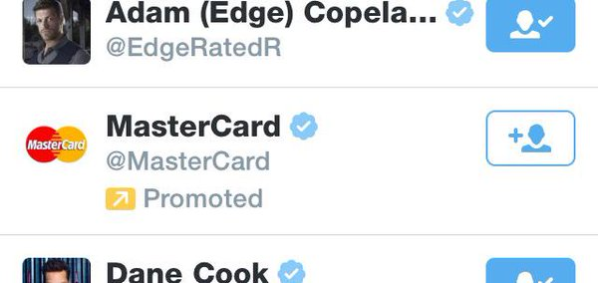

Entertainer Dwayne “The Rock” Johnson only follows one person, but his “following” page displays:

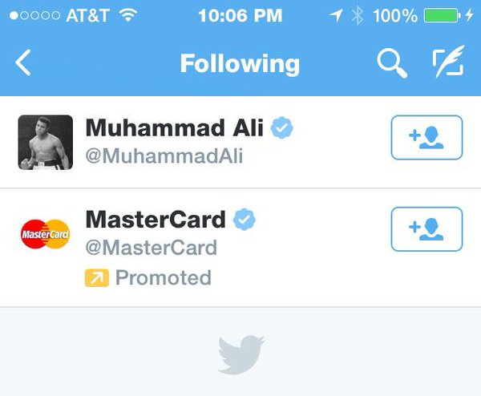

President Barack Obama’s “following” page (see the middle image on the second row):
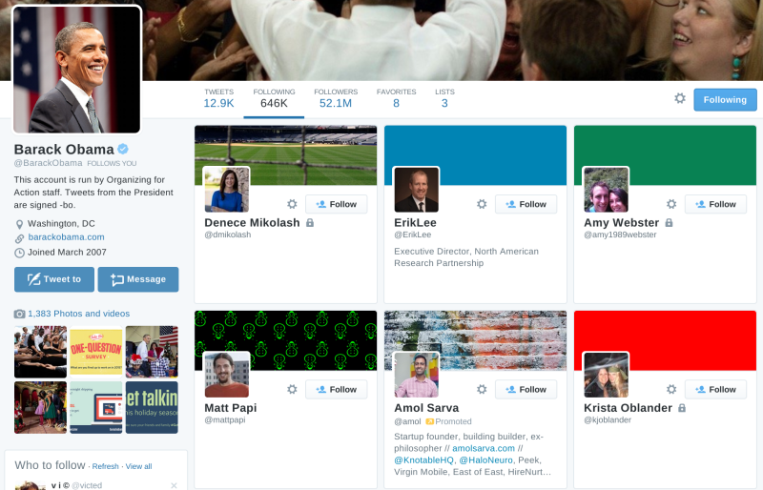

And the official Visa account, @Visa (Visa is MasterCard’s main competitor):

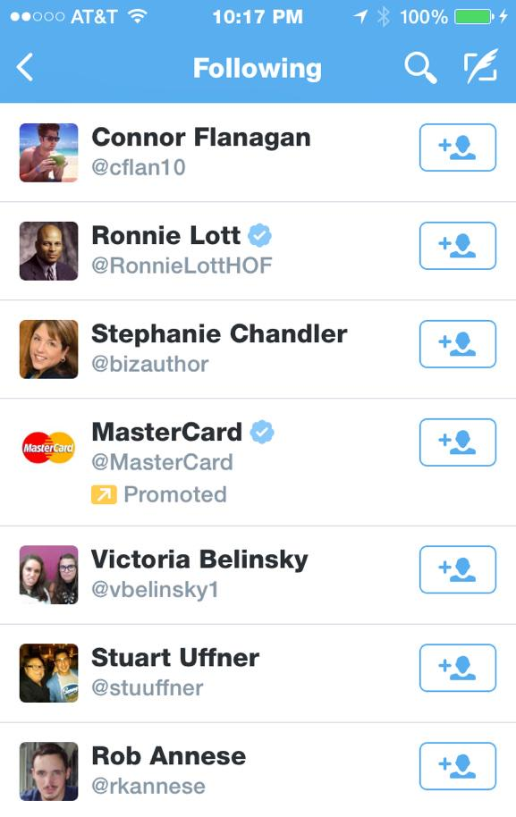

Twitter’s terms of service include the following, which is the only relevant language; assume that these terms are part of a valid contract, and that no arbitration provision controls:

The services provided by Twitter may include advertisements, which may be targeted to the content you provide or information on the services, queries made through the services, or any other information. The types and extent of advertising by Twitter on the services are subject to change. In consideration for Twitter granting you access to and use of the services, you agree that Twitter and its third party providers and partners may place such advertising on the services or in connection with the display of content or information from the services whether submitted by you or others.

For these purposes, New York state law applies, as well as federal law; do not limit yourself to Second Circuit precedent when analyzing federal law. Identify and evaluate the potential claims of Shatner and Visa against Twitter and MasterCard, including potential defenses.

Question 2: Lyft (30 points)

Uber is a popular car service, which is used to replace standard taxi service. It has a number of competitors, the most successful of which is Lyft. In order to combat the threat from Lyft, Uber has adopted a number of tactics, including “Operation Slog,” described below:

Uber hired teams of independent contractors it calls “brand ambassadors,” providing them with iPhones and credit cards. The brand ambassadors hail rides, strike up conversations with their drivers, and attempt to sign them up with Uber before they arrive at their destination. Brand ambassadors can earn a $750 commission for successfully recruiting a single new driver to Uber.

Brand ambassadors cancel rides if the driver assigned by Lyft has already been solicited by an Uber brand ambassador. Cancelled rides harm Lyft drivers and Lyft, making driving for Lyft less attractive. One analysis by Lyft identified 5,560 Lyft rides ordered and then cancelled by Uber employees and contractors in the last month, in the five largest Lyft markets. Lyft arrived at this figure by cross-referencing the phone numbers of users who tried to recruit Lyft drivers to Uber with users who had previously canceled rides.

In statements to investors, the press, and FAQs on its website for drivers and for riders, Uber states that it does not encourage employees or independent contractors to order and then cancel rides, because that costs drivers money. However, in its internal directives to its brand ambassadors, who must sign a confidentiality agreement to work with Uber, it does direct them to (1) record the information about any driver they ride with and solicit in a central database, and (2) check the central database of drivers after they’ve ordered a ride, and cancel any ride with drivers who’ve already been solicited. The reason is not to deprive Lyft drivers of money (though that is not exactly a horrible side effect from Uber’s perspective) but to avoid detection by Lyft, since Lyft asks its drivers to report solicitation attempts from Uber, and Lyft will cancel accounts associated with phone numbers or credit cards that have been linked to Uber. In fact, anticipating Lyft’s reaction, brand ambassadors are given multiple phones and credit card numbers, so that they can create new dummy accounts when an account is cancelled.

Here is a portion of the “pitch” that brand ambassadors are directed to use:

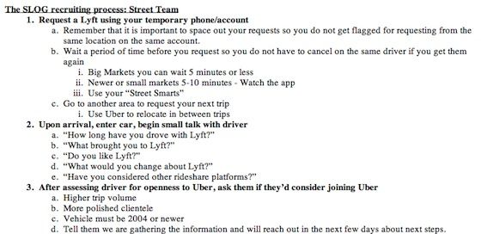

Although Uber does have higher trip volume in 8 out of the 10 largest markets, it pays drivers less per mile driven than Lyft does. Lyft additionally allows drivers to accept tips, as Uber does not. Demographically, Uber’s users are slightly older and make somewhat more money (average age of Lyft user, 25; average age of Uber user, 28; average income of Lyft user, $40,000; average income of Uber user, $45,000).

Identify and evaluate potential claims against Uber from the FTC and from Lyft. (If you are familiar with the CFAA: do not consider potential CFAA claims against Uber.)

Question 3: Kashi (20 points)

“Natural” foods were a $22.8 billion industry in 2009, and the market continues to grow today. Kashi markets itself as providing “Real Food Values “ and being “7 Whole Grains on a Mission.TM” It offers consumers the “Kashi Ingredient Decoder,TM”: a “handy tool [that] will help you figure out what’s real on ingredient labels.” E.g.:
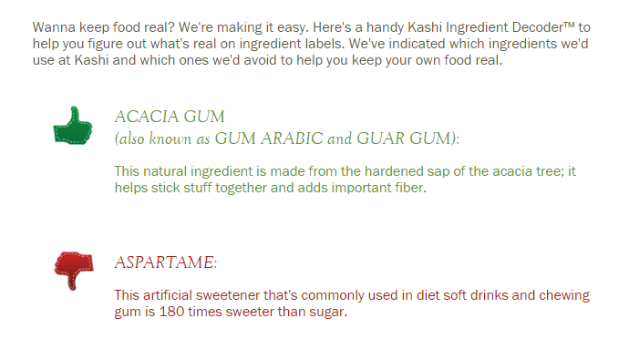

The FDA has stated that a product is not natural if it contains synthetic or artificial ingredients, but it has so far declined to create a detailed definition of natural; it has recently opened an inquiry into whether it should do so.

Federal regulations say that a synthetic substance is “[a] substance that is formulated or manufactured by a chemical process or by a process that chemically changes a substance extracted from naturally occurring plant, animal, or mineral sources, except that such term shall not apply to substances created by naturally occurring biological processes.” Also, an ingredient is artificial if it “is not derived from a spice, fruit or fruit juice, vegetable or vegetable juice, edible yeast, herb, bark, bud, root, leaf or similar plant material, meat, fish, poultry, eggs, dairy products, or fermentation products thereof.”

For meat, the USDA defines a “natural” product as a product that does not contain any artificial or synthetic ingredient and does not contain any ingredient that is more than “minimally processed”:

Minimal processing may include: (a) those traditional processes used to make food edible or to preserve it or to make it safe for human consumption, e.g., smoking, roasting, freezing, drying, and fermenting, or (b) those physical processes which do not fundamentally alter the raw product and/or which only separate a whole, intact food into component parts, e.g., grinding meat, separating eggs into albumen and yolk, and pressing fruits to produce juices. Relatively severe processes, e.g., solvent extraction, acid hydrolysis, and chemical bleaching would clearly be considered more than minimal processing. . . .

The USDA does not have authority to regulate non-meat products.

Kashi itself uses the following definition of “natural” on its website:
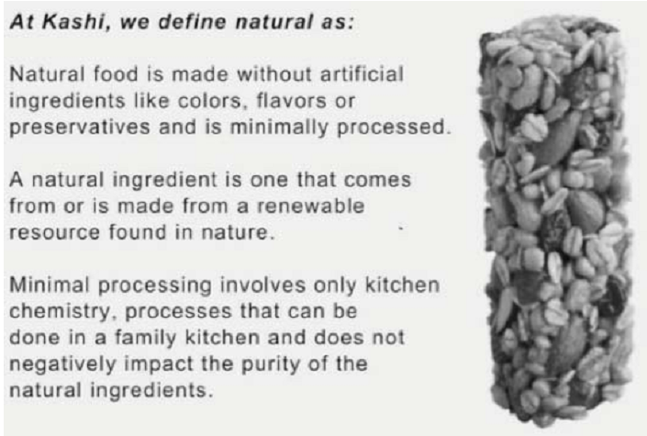

Kashi prominently displayed the promises “all natural” and “nothing artificial” on the front labels of almost all—but not all—of its products. However, Kashi’s “All Natural” GoLean Shakes have as significant ingredients such as sodium molybdate, phytonadione, sodium selenite, magnesium phosphate, niacinamide, calcium pantothenate, pyridoxine hydrochloride, thiamin hydrochloride, and potassium iodide.

The producers of the relevant ingredients began with plants, but extensively processed them in order to extract the chemicals/precursor chemicals. According to federal definitions, calcium pantothenate “is prepared synthetically from isobutyraldehyde and formaldehyde via 1,1-dimethyl-2-hydroxy-propionaldehyde and pantolactone.” Under federal regulations, magnesium phosphate can be prepared in one of two ways: by treating magnesium sulfate with disodium phosphate; or by treating magnesite with phosphoric acid, a s hazardous substance. Niacinamide “is the chemical 3-pyridinecarboxylic acid amide (nicotinamide).” It and thiamin hydrochloride are recognized as synthetic organic chemicals by the U.S. International Trade Commission. Potassium iodide is “prepared by reacting hydriodic acid (HI) with potassium bicarbonate.” Sodium molybdate has not been declared to be generally recognized as safe by the FDA. Sodium selenite has not been declared generally recognized as safe as a food additive by the FDA, but it is approved for use as an animal feed additive.

In addition, the soy protein in Kashi shakes comes from genetically modified soybean plants. A Technical Advisory Panel addressing the requirements of the Organic Foods Production Act of 1990 concluded that it was a synthetic substance for purposes of the organic food regulations.
Ichabod Crane, a purchaser and resident of California, sues Kashi under California’s consumer protection laws (the False Advertising Law, the Unfair Competition Law, and the Consumer Legal Remedies Act, though you need not consider each one separately) on behalf of a California class of purchasers of the product, alleging that the All Natural/nothing artificial claims are false and misleading. Identify the key issues and suggest how they should be resolved.

