Question 1: Twitter (25 points)

Twitter begins an advertising program in which “promoted” brands are added to the list of Twitter accounts that shows up on a Twitter user’s “following” page, which otherwise shows accounts that the user is actively following/receiving tweets from. The promoted brands will not show up in the user’s Twitter feed unless the user actually follows the relevant account, but other users who look at the user’s “following” page, perhaps to get suggestions for their own reading, will see the promoted brands.

From William Shatner’s “following” page (Shatner is best known for playing Captain Kirk on Star Trek, and as a Priceline spokesperson):

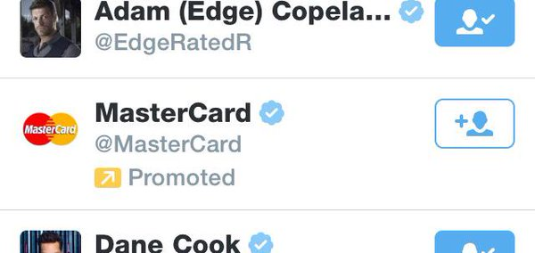

Entertainer Dwayne “The Rock” Johnson only follows one person, but his “following” page displays:

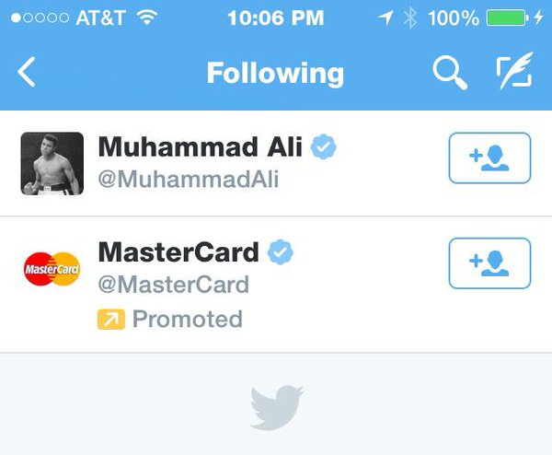

President Barack Obama’s “following” page (see the middle image on the second row):
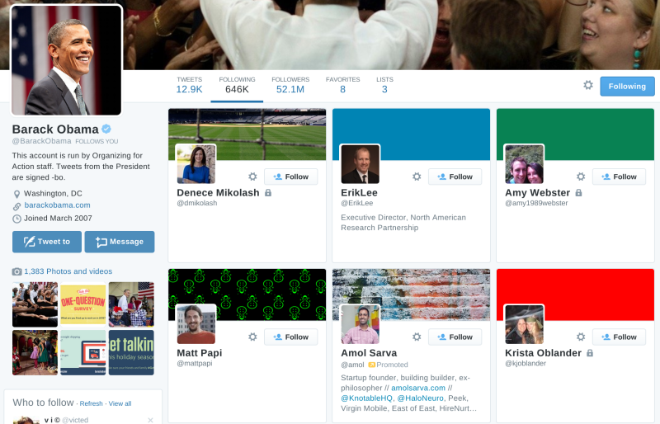

And the official Visa account, @Visa (Visa is MasterCard’s main competitor):

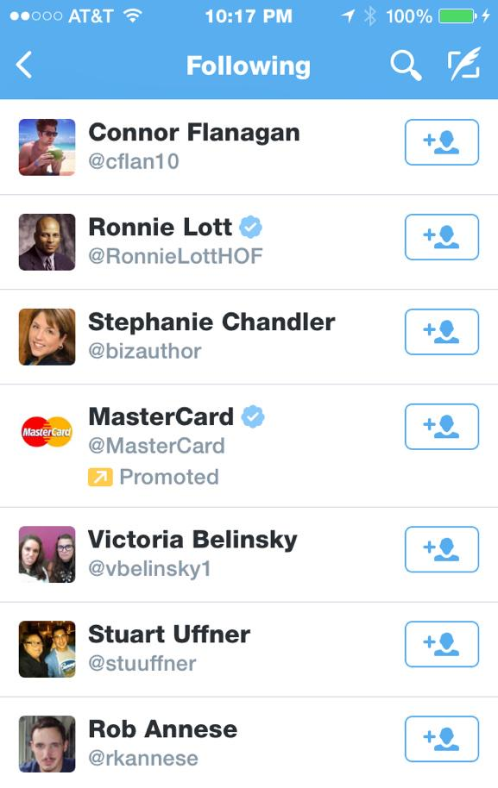

Twitter’s terms of service include the following, which is the only relevant language; assume that these terms are part of a valid contract, and that no arbitration provision controls:

The services provided by Twitter may include advertisements, which may be targeted to the content you provide or information on the services, queries made through the services, or any other information. The types and extent of advertising by Twitter on the services are subject to change. In consideration for Twitter granting you access to and use of the services, you agree that Twitter and its third party providers and partners may place such advertising on the services or in connection with the display of content or information from the services whether submitted by you or others.

For these purposes, New York state law applies, as well as federal law; do not limit yourself to Second Circuit precedent when analyzing federal law. Identify and evaluate the potential claims of Shatner and Visa against Twitter and MasterCard, including potential defenses.

Shatner could claim that the MasterCard campaign violates its right to publicity. In
new York, right of publicity claims are governed by NY statue, and Common law claims
are not recognized (Arrington v. New York Times Co; Allen v. National Video; Onassis
v. Christian Dior). Under New York law, it is illegal use the “name, portrait or picture” of
a person, for “advertising purposes”, without consent. In our case, Twitter and
MasterCard clearly used Shatner’s “name” and “picture”. Since the following page of his
account is accessible trough his account’s home page, which contains his name and
picture. As the Obama example shows, the following list is also often displayed along
side the account owners’ name and picture, and the MasterCard campaign obvious
intention is to create link between MasterCard and the account owner, in this case
Shatner. The lack of consent requirement also met, as MasterCard or Twitter never
received Shatner’s consent for this Type of advertising. Nevertheless, Twitter can claim that its user agreement provides an adequate consent. It would specifically refer to the
section allowing Twitter to “place” advertising on Twitter “in connection with the display
of content or information from the services whether submitted by you or by others”. This
language seems inadequate to support publicity rights waiver, particularly because it
doesn’t refer to this issue specifically, and doesn’t’ disclose that Twitter might post or
create content in the user’s name. This language also seems over broad, and users can
claim Twitter action exceed their initial contract (c.f. Robert Keiley’s claims against the
Law firm to which he gave broad consent).
It seems that the commercialization requirement is also met. MasterCard and
Twitter have chosen to out the MasterCard ad specifically on famous persons of
companies following lists. This decision is intended to trade on the value associated with
these figure. And, indeed, putting the MasterCard ad on Shatner’s popular twitter account
increases the chance of other users – valuing Shatner and wanting to see who dies he
follow – will be exposed to the ad. Attracting consumer attention was identified (tough
not in NY) as commercialization of a person name (Henley v. Dillard Department
Stores). It also increases the credibility and value that other users seeing the ad will apply
to it, as they have seen it on the valuable celebrities’ following list. These benefits don’t
seem incidental. In fact, the mere fact that MasterCard agreed to pay Twitter for this
specific placement suggest that is saw some value in it (Allen; Onassis). To conclude,
Shatner probably has a valid publicity right claim. It should be also noted that, depending
on Shatner level of famousness and the use he had made with his personality (whether he
used it “in commerce”) Shatner might also have personality trademarks in his name. Even if trademark is available, Shatner might prefer to focus on publicity rights as in trademark
he will have to prove likelihood of consumer confusion and secondary meaning (as his
name is descriptive), which will probably require expensive surveys. Shatner potential
trademark claim will closely resemble Visa’s trademark claim, which I will now address.

Twitter's promoted brands advertising program raises several issues:
First, in the case of William Shatner, a well-known public figure who routinely endorses
travel-related commercial enterprises such as Priceline, the placement of the MasterCard
brand on his page could lead a reasonable consumer to believe that Shatner is an endorser
of MasterCard. This is especially more reasonable to believe since MasterCard routinely
advertises the travel and leisure-related benefits of its cards. This presents several issues
around endorsement, right to publicity, privacy and the lack of necessary disclosure.
The same is not entirely true for Visa. It is unlikely that a reasonable consumer acting
under the circumstances would believe that Visa was endorsing MasterCard, its direct
competitor. Visa could argue that the placement of the MasterCard brand on Visa's
twitter page could lead consumers to believe that the two companies had merged, or that
Visa had chosen to endorse MasterCard, however, this argument is unlikely to pass
muster. A better, though equally challenging option is for Visa to pursue a trademark
infringement and trademark dilution litigation against MasterCard for 'Using the Visa
mark in Commerce'.

Placing the MasterCard twitter account among the accounts that a person or company
appears to be following may send the message that the person or company is following
that account. While it may be up for debate what it means to follow a twitter account, that
is, what precise message it sends, if any, it at least conveys that the person or company
did so intentionally. It suggests that they had a reason for doing so, whether it was
because they think the account is interesting or funny or they just want to keep an eye on
MasterCard. Whatever the message, many people cultivate the list of people they're
following very intentionally. For example, The Rock is following just one person,
Muhammad Ali. Presumably The Rock means that to send a message about how much he
values Ali compared to others. It's also a kind of statement about how cool the person is
if they follow only a handful of people, follow fewer people than follow them, or follow
only accounts they endorse. I will discuss the likelihood of specific messages the
MasterCard ads could convey in the following sections, particularly in light of the
"promoted" disclosure. It may be important to do some studies about what consumers
take away from the ads in order to know what the best strategy is for Shatner and Visa.

The prominence of twitter's "promoted" disclosure depends on the screen view. The
disclosure on the sidebar view is fairly prominent. It makes the MC line larger than others
because it includes more text, which might draw the eye to the disclosure and encourage
the consumer to think about what it means. On the full page view, as in the Obama
screenshot, however, the prominence of the promoted line is minimized. it looks like part
of the text of the person's profile. A consumer might not even notice it and assume that
this person is someone POTUS values enough to follow, which is clearly what that
person wanted out of the advertising money. The little orange symbol adds some
prominence to the word promoted, but may also be overwhelmed by other colors and
words on a page with a lot of information. Similarly, the effectiveness of the presentation and placement varies since the promoted tag gets washed out in some views. The
proximity of the disclosure is good, though, because it is very close to other relevant
information. Taking into account the sophistication of twitter uses may cut both ways on
the effectiveness of the disclaimer. On one hand, if promoted accounts are common, then
people who use twitter a lot may know and recognize them as ads. On the other hand,
twitter is widely used by all sorts of people, so it may not be possible to nail down a base
level of sophistication regardless.

As a threshold matter, Twitter and MasterCard make a potentially misleading claim by
listing "promoted" brands under users' "following" pages. The key phrase here is the
word "promoted." From the context of a user's "following" page alone, it is unclear what
is meant by "promoted." A Twitter user may presume that the celebrity himselfis
"promoting" the brand when the brand appears on his "following" page. Alternatively, a
user may understand that "promoted" means that Twitter promotes the brand--as opposed
to the celebrity doing the promoting. At the very least, the word "promoted" can be
misleading to a reasonable consumer.
Moreover, the disclosure in Twitter's terms of service (TOS) provides no safe harbor.
While Twitter's terms of service discuss the inclusion of advertisements, this does not
meaningfully disclose a definition for, or provide context to, the word "promoted." The
terms of service are not clear and conspicuous, and do not appear on the same screen as
the "promoted" brands. The disclosure thus fails all "Four Ps" put forth in FTC
guidelines. (1) The TOS are not prominently displayed on Twitter's website, and users are
unlikely to ever read the TOS. (2) The presentation is not user friendly. From the TOS
alone, It is unclear to an average consumer that "promoted" products mean "promoted"
by Twitter, and not by the celebrity whose page the promoted brands appear on. (3) The
TOS are not placed where consumers are likely to look. At best, consumers see the TOS
once when they sign up for Twitter. This is insufficient for a proper disclosure. (4) Finally, and most troublesome, the TOS are not placed in proximity to the following
pages. Instead, the TOS are on separate pages entirely.
In sum, the TOS does not adequately disclose or provide appropriate context for the word
"promoted." Without an adequate disclosure, the word "promoted" can lead to liability
for Twitter and MasterCard.

N.Y. General Business Law (GBL) 349
Shatner may also be able to state a claim for unfair and deceptive practices under
ew York law, but it is unlikely to succeed. See NY GBL 349. Under GBL 349 a
laintiff must show that defendant’s conduct was: (1) consumer oriented; (2) deceptive or
isleading in a material way; and (3) that plaintiff suffered injury as a result. Gomez
While he can
argue, as in the Lanham Act claim, that the practice is deceptive, the deception is unlikely
to be material. While it’s possible to imagine some consumers switching to Mastercard
because of Shatner’s endorsement, it seems implausible that it would be material to the
majority. Credit card services are ubiquitous, and choice of services is much more likely
to rest on features of the service itself, financial incentives, and partnership deals (for
example, with banks or stores) than a perceived celebrity endorsement. The court in
Gomez-Jimenez rejected a claim that reasonable consumers would find law school
graduation statistics material in the choice of law schools, and it seems equally unlikely
that reasonable consumers would be persuaded to switch credit cards based on who
Shatner is following, here.

While the Twitter TOS
provides that Twitter can include targeted advertisements, there is no indication that
Shatner explicitly agreed to have his name and picture used. The last sentence of the TOS
states that advertisements can be placed on "the content or information" submitted by
users. Given that permission to use Shatner's name or image would fundamentally alter
the nature of the contract, I doubt that a court would find that such vague language
provides permission to exploit Shatner's publicity rights. Moreover, courts tend to be
celebrity friendly when it comes to their publicity rights. See, e.g., Abdul-Jabbar v.
General Motors. Thus Shatner would likely have publicity rights claim under New York
law.

Shatner may have registered a copyright on the tweets of his twitter account, since
they are expressive writings fixed in a medium and the copyrightability of expression is
broadly construed. See, e.g., Web Loyalty, SKyy Vodka. We would have to ask how much
of his twitter page is within the copyright’s scope and how much is owned by Tiwtter in
terms of design and page layout. However, as in the Shaklee case, the presence of the
Mastercard ad on Shatner’s page might create a derivateive work “consisting of . . .
annotations . . . or other modifications which, as a whole, repreent an original work of
authorship.” <<SOURCE>>. This is likely a weak claim, and it depends on the scope of
the original copyright license breached (complicated by the twitter platform’s
interference). This is also likely a weak claim because a court may simply find the ad to
be a “noninteracting element” that does not interfere with Shatner’s copyright, especially
since the ad appears nowhere near the content of his tweets. See, e.g., Pramount pictures,
Target However, since the ads appear on his
"followers" page and not on his main page that contains his Tweets, Shatner is unlikely to
succeed on a copyright claim.

Visa could also bring a trademark dilution suit under the Lanham Act. Visa almost
certainly has a registered trademark in the word Visa, and its logo. Visa's name and logo
also appear on its "following" page. Visa might argue that, by including the MasterCard
ad on its page, Twitter is diluting the uniqueness of its mark by blurring its
distinctiveness. See Deere v. MTD. Visa could argue that its mark would be "whittled
away" over time. However, like in Deere, the juxtaposition poses a slight risk of blurring
at best. Notably, the Visa and MasterCard marks routinely appear in close proximity in
both e-commerce (when someone is checking out online), and in physical stores (i.e. the
stickers displaying which credit cards the store accepts). Thus I am not sure a dilution
claim would succeed, since consumers are not deceived by those examples (I assume). In
any event, Twitter might argue that it has an explicit or implicit license to use Visa's TM
as per the terms of service, but this would require more information.

The contractual language includes an agreement from the user (Shatner) that allows
Twitter and its third party providers/partners to place advertising, in any form, on or in
connection with information (presumably including Shatner's name and picture) provided
by William Shatner or other users. Because Shatner (or an agent of his) agreed to these
terms upon signing up for the service, the "without permission" prong fails. Finally, the permission question applies here too - Twitter's permission that they obtained specifically applies to third-party providers and partners, which by its terms covers Mastercard. The permission obtained by Twitter should cover Mastercard.

Mastercard shows up in a list of accounts that Visa follows could be seen as a claim that
Visa follows Mastercard. Assuming Visa does not follow Mastercard on Twitter, this
claim could be false or misleading.
Also other false “endorsements” could harm Visa by suggesting that Mastercard is the choice of celebrities.
Twitter is an interstate platform and the "claim" would be in connection with commercial
advertising or promotion.
However, the last few prongs are more problematic. It's not clear that this "claim"
actually deceives or has the tendency to deceive an appreciable number of consumers in
the intended audience. To the extent that Twitter's disclosures that the promoted account
is an ad are effective, consumers should not be deceived. Even if they were, it's unclear
that this is a material claim that is likely to cause injury to the plaintiff. The fact, even if
true, that Visa followed Mastercard on Twitter doesn't seem like something that would
affect a buyer's decision to choose Mastercard over Visa.

Despite the presence of the disclaimer stating "Promoted," the very appearance on
the "Following" tab in Twitter may be found to make this false. Essentially, the
placement of the ad states "This is an account followed by William Shatner," and then the
disclaimer says, "Actually, Shatner does not follow this account." In Citicorp Credit
Services, an ad depicting Citibank replacing a toy that had broke included the disclaimer
that Citibank would actually just reimburse for the cost of replacement, but not actually
replace the toy. Advertisers are not allowed to use change the ordinary meaning of their
claims via a disclaimer. Without a substantial rejiggering of the disclaimer, this ad cannot
work. The FTC recommends that some ads may not be able to run if there is not room for
proper disclosures (McCarthy, Yes, New FTC Guidelines Extend to Facebook Fan
Pages).

Under Lexmark, the proximate cause inquiry begins
by asking whether consumers would believe the misrepresentation. This seems unlikely,
since consumers will be aware that Visa and Mastercard are direct competitors which
seemingly makes it less likely that the presence of Mastercard in Visa’s “following” feed
would be interepretted as association or endorsement. Instead, the inference that
consumers are likely to make is that Visa is aware or Mastercard, and wants to see what they put out over their Twitter feed. Visa may therefore fail this aspect of the proximate
cause analysis. If Visa could establish that consumers believed they were endorsing,
sponsoring, or approving of Mastercard by following them on twitter, however, the rest
of the proximate cause inquiry would follow easily, since they would likely be harmed by
that consumer belief. If Visa satisfied standing requirements for 43(a)(1)(A) by showing
that customers were mislead into thinking that they endorsed Mastercard they would also
be likely to win on the merits, however for reasons discussed above, Visa is unlikely to
be able to show that reasonable consumers would be mislead, and the 43(a)(1)(A) claim
is therefore likely to fail.

230: However,
because the illegality of the claims here comes from the mere fact that there are
endorsements at all on Shatner’s page that he didn’t expressly consent to in writing
(publicity claims) or otherwise, leading to potential confusion about their endorsement
status (trademark claims), Shatner may be able to argue that Twitter did contribute to
their illegality. This might be a tough case to make due to strong policy reasons for
protecting online publishers, but since the acts are all commercial in nature (twitter’s
advertising, not other speech), he may have a shot with this.

Question 2: Lyft (30 points)

Uber is a popular car service, which is used to replace standard taxi service. It has a number of competitors, the most successful of which is Lyft. In order to combat the threat from Lyft, Uber has adopted a number of tactics, including “Operation Slog,” described below:

Uber hired teams of independent contractors it calls “brand ambassadors,” providing them with iPhones and credit cards. The brand ambassadors hail rides, strike up conversations with their drivers, and attempt to sign them up with Uber before they arrive at their destination. Brand ambassadors can earn a $750 commission for successfully recruiting a single new driver to Uber.

Brand ambassadors cancel rides if the driver assigned by Lyft has already been solicited by an Uber brand ambassador. Cancelled rides harm Lyft drivers and Lyft, making driving for Lyft less attractive. One analysis by Lyft identified 5,560 Lyft rides ordered and then cancelled by Uber employees and contractors in the last month, in the five largest Lyft markets. Lyft arrived at this figure by cross-referencing the phone numbers of users who tried to recruit Lyft drivers to Uber with users who had previously canceled rides.

In statements to investors, the press, and FAQs on its website for drivers and for riders, Uber states that it does not encourage employees or independent contractors to order and then cancel rides, because that costs drivers money. However, in its internal directives to its brand ambassadors, who must sign a confidentiality agreement to work with Uber, it does direct them to (1) record the information about any driver they ride with and solicit in a central database, and (2) check the central database of drivers after they’ve ordered a ride, and cancel any ride with drivers who’ve already been solicited. The reason is not to deprive Lyft drivers of money (though that is not exactly a horrible side effect from Uber’s perspective) but to avoid detection by Lyft, since Lyft asks its drivers to report solicitation attempts from Uber, and Lyft will cancel accounts associated with phone numbers or credit cards that have been linked to Uber. In fact, anticipating Lyft’s reaction, brand ambassadors are given multiple phones and credit card numbers, so that they can create new dummy accounts when an account is cancelled.

Here is a portion of the “pitch” that brand ambassadors are directed to use:

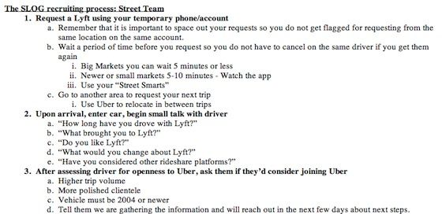

Although Uber does have higher trip volume in 8 out of the 10 largest markets, it pays drivers less per mile driven than Lyft does. Lyft additionally allows drivers to accept tips, as Uber does not. Demographically, Uber’s users are slightly older and make somewhat more money (average age of Lyft user, 25; average age of Uber user, 28; average income of Lyft user, $40,000; average income of Uber user, $45,000).

Identify and evaluate potential claims against Uber from the FTC and from Lyft. (If you are familiar with the CFAA: do not consider potential CFAA claims against Uber.)

As an initial matter, it should be noted that Uber can likely be held liable for the
actions of its independent contractors and employees. The FTC has stated that liability is
appropriate “when the defendant participated directly in the violative conduct or had
authority to control it,” and had or should have had knowledge of it. (FTC v. Lights of
Am). In this case, the specific Operation Slog instructions make it very clear that Uber
was aware of and directly encouraged the conduct of its employees and independent
contractors. This principle applies for claims outside of the FTC context as well. In P&G
v. Haugen, the court established that “An agent is “a person authorized by another to act
on his behalf and under his control.” In that case, the court made much of the fact that the
distributors were not expressly or implicitly told to spread the violative messages. (Id.).
This is clearly not the case for Uber, which provided explicit instructions to its Operation
Slog contractors. As a result, Uber should be liable for their actions.

On some level, Uber's scheme is brilliant. In the extremely competitive rideshare
wars, with both companies valued in the billions, Uber has found a way to conduct very
targeted advertising. Whereas a billboard ad would be viewed mostly by people
uninterested in driving for Uber, Uber's Operation Slog targets precisely the segment
Uber wants to reach: people who own cars and want to drive for a ride sharing service.
Unfortunately for Uber, many elements of this scheme are also illegal. As vaunted "two-side platforms," Uber and Lyft actually have two sets of
customers: riders and drivers. While drivers are also (controversially) independent
contractors, for this analysis, we can consider them customers because Uber and Lyft
both compete for their business. In a way, almost all company employees are customers
at some level (think about the great efforts Google makes to recruit and retain top talent).
In the rideshare wars, drivers are very obviously a key market for advertising. Each driver
and rider increases the value of the platform and anything done to hurt their experience
will be harmful to Lyft.
Lyft claims against Uber under the Lanham Act
The Lanham Act provides a general cause of action for competitor falseadvertising. In particular, § 43(a) has very broad language stating, "…any false
description or representation, including words or other symbols tending falsely to
describe or represent the same…shall be liable to a civil action by any person…who
believes that he or she is likely to be damaged by the use of any such false description or
representation." The activities of Operation Slog are a false representation from the way
the brand ambassadors reach the drivers to the misleadingness of their message. Lyft is
harmed in multiple ways: their service suffers in the short-term (drivers frustrated by
canceled rides, real passengers unable to get a ride as drivers' time is wasted on 'fake' and
canceled rides) and long-term (drivers leave the platform, which diminishes its value to
other drivers, riders and ultimately Lyft itself).
The Lanham Act requires a six-factor inquiry: (1) false or misleading statement of
fact; (2) in interstate commerce; (3) in connection with commercial advertising or
promotion; (4) that actually deceives or has the tendency to deceive an appreciable
number of consumers in the intended audience; (5) that is material; (6) that is likely to
cause injury to the plaintiff. For our purposes, (2) is always satisfied and we will focus on
the other requirements.
Canceling trips significantly harms Lyft drivers, riders and the company itself.
Actions by the brand ambassadors count as commercial promotion. When a brand
ambassador calls a Lyft, they have no intention of actually using the service for its
intended purpose, so it is in essence a false statement. The fact that they undertake
elaborate schemes to stay a step ahead of Lyft's detection proves that they are very aware
that the conduct is harmful to Lyft. The significant effort to avoid detection is akin to
failing to disclose a material fact about their call (because if they did, Lyft would kickthem off the system). The annoyance of canceled rides certainly tarnishes the Lyft brand
(Deere v. MTD).
If a certain number of drivers actually defect from Lyft to Uber, the Lyft platform
is less valuable and Lyft loses their portion of revenue from that driver. The fact that the
Lyft drivers are already part of the network (i.e. Lyft customers) is important to
distinguish this harm from the unrecognized harm in Google v. American Blind, where
the court did not find proximate cause for economic harm because American Blind's
expectation of "future and prospective" sales was too speculative. Here, Lyft is losing a
real customer and the pain is anything but speculative. The fact that Uber is willing to
pay $750 per driver recruited is a clear indication that there is real value in attracting
drivers to the platform. The result of this activity (drivers leaving Lyft and joining Uber)
is doubly harmful to Lyft because they lose a customer while their biggest competitor
gains one.
The "higher trip volume" claim and other aspects of the brand ambassador pitch to
drivers may be considered false by necessary implication.
Higher trip volume is only desirable if it leads to more money for drivers. While
the claim is not explicitly false (in 8/10 of the largest markets Uber does have higher trip
volume), the implied statement is that drivers will personally have a higher volume and
(more importantly) they will make more money. The 8/10 stat may be enough to say that
Uber has a reasonable basis for making volume claims. We do not know the truthfulness
about whether drivers individually have higher volumes or if there are just more drivers
to share the higher volumes. The most important thing to drivers would be that they make
more money and this does not appear to be the case since the per mile payments and tipsare lower with Uber. Omitting material facts in comparative advertising can make a
statement misleading (San Juan Star v. Casiano). Additionally, by failing to disclose the
lower rates and discussing Lyft's flaws without bringing up any of Uber's issues, they
have created a 'apples-to-oranges' comparison in which Uber looks better (E.R. Squibb).
The fact that Uber knows drivers care about mileage rates and fails to disclose them
could also be cause for action (Gillette v. Norelco).
The statement is not literally false, even by the relatively expansive definition in
Avis v. Hertz. While the jump from "higher total volume" to "more money per driver" is
perhaps larger than the necessary implication in Cuisinart v. Robot-Coupe (where a court
found falsity by necessary implication), but does not seem like a stretch compared to
Veve v. Corporan in which pictures of sites implied that they were part of the tour. The
implied falsity at issue seems to be similar to McNeil-PPC v. Pfizer in which a court
found that saying that Listerine's benefits were similar to floss implied that Listerine was
a replacement to floss. Here, stating higher trip volume without disclosing the lower pay
per mile and lack of tips could be implied falsity.
To prove this claim, Lyft would likely require a survey. Requirements for a good
survey include open ended (non-leading) questions and are laid out in Rocky Brands v.
Red Wing Shoe Co. The relevant universe of respondents would be Lyft drivers (current
and past) since that is who the pitch was meant to impact (Amstar v. Domino's Pizza).
Of course, the entire pitch is delivered under false premises, as the 'rider' is
actually a brand ambassador. The FTC claims surrounding failure to disclose
consideration (discussed later) could also apply to Lyft's Lanham Act claim.
Use of the term "more polished clientele" is harmful to Lyft and not backed by anyfact.
In making the claim that the clientele is more polished, Uber is relying upon the
demographics, which indicated that Uber riders are slightly older and slightly higher
earning on average. Using the term "polished" without expressly saying "older" and
"wealthier" possibly implies that there could be something dangerous or unsavory about
Lyft's riders. Lyft could argue that customers will interpret the claim in this way and
would be misled (Cashmere & Camel Hair Manufacturers Institute v. Saks Fifth Avenue).
Uber may claim that the "polished" claim is just puffery since there is no established fact
for polish. In reality, there may also be some racist or ageist connotations related to this
claim, which Uber is using to try to scare drivers. Unlike the other claims listed, this
claim may have trouble being deemed material to a customer's decision making process
(Mead Johnson v. Abbott Labs). This is particularly problematic for Lyft if Uber can
show that the drivers are not influenced by the claim; of course, if Uber does not think
drivers are influenced by the claim, why would they advise the brand ambassadors to say
it?
This claim is also possible under § 5 of the FTCA (more of those claims discussed
below). The claim has the feel of "push polling" techniques and could ultimately harm
minority or young consumers (who drivers may rate lower and ultimately exclude from
the service).
The FTC could conclude that it is reasonable of the Lyft driver in those circumstances to
assume that statements made about trip volume are in reference to the market in which he
is currently driving the brand ambassador. Once again, the FTC is not required to provide
evidence of consumer reception, and the fact that Uber has specifically asked its brand
ambassador to make these express claims (or has intended to make the implied claims)
suggests that FTC can presume materiality that is difficult to rebut (Kraft).
Uber could argue that Lyft drivers are a sophisticated consumer and that they
should be expected to inquire more deeply when considering switching employment.
After all, the decision to drive with Uber instead of Lyft is not the same as deciding
between two brands of shampoo (similar to choosing a law school in Gomez-Jiminez v.
New York Law School, although that is state law and not controlling). Still, the FTC has
a strong case that Uber has made a material statement that is implicitly false.
FTC claims against Uber under §5
[Unfairness] ,
For reasons discussed above, it is fair to treat drivers as customers in this
circumstance. Additionally, Uber's actions also have an impact on riders. The FTC can
bring a claim under § 5 of the FTCA, which prohibits "unfair or deceptive act or
practices." To prevail, the FTC must establish that:(1) there was a representation
(2) that was likely to mislead a "not insubstantial" number of consumers acting
reasonably under the circumstances, and (3) that the representation was material to
consumers (i.e. likely to impact consumer choice and/or conduct regarding a product).
Most broadly, the FTC attempts to uphold their two pillars of truth in advertising:
advertising must be truthful and not misleading; advertisers must have adequate
substantiation for all their claims before disseminating their advertising. We will examine
various actions and claims made by Uber to see whether there is a reasonable cause of
action under § 5.
Statement to investors, the press and FAQ's on its website for drivers and riders is
untruthful.
Uber's denial that they encourage employees or independent contractors to order
and then cancel rides is false. This statement, appearing on the website and in other
promotions is clearly commercial speech (Kasky v. Nike). Under Central Hudson, false
commercial speech is not protected. This claim easily meets all three requirements
necessary for a § 5 claim. They represent that they have not encouraged brand
ambassadors to cancel Lyft order (satisfying 1), the claim is clear and on their website,
thus likely to mislead many people (satisfying 2) and the claim is important to both
drivers and riders because they do not want to support a business that engages in such
unethical practices (satisfying 3). Since this is a statement that is literally false, there is no
need to further investigate to see if consumers are actually mislead. Uber could not try toget out of this with a puffery claim (Pizza Hut v. Papa John's).
Ordering false rides and canceling harms both drivers and riders (both considered
customers of Lyft).
The representation at issue is the brand ambassador's ordering a Lyft. In many
cases (5,560 times), drivers were misled into thinking they had a pickup to make when
there was not one. This materially impacted drivers' actions because they would lose
valuable time responding to the order. This would make them less likely to want to drive
with Lyft since it decreased their pay and increased their frustration. This was no "mere
trifle" (Harris v. Time). For passengers, the service is less valuable when drivers are busy
with false calls, frustrated by false calls or choose to leave because of false calls. These
actions by brand ambassadors (encouraged by Uber) were objectively false and would not
be in the gray area of a case like Vokes v. Arthur Miller where there is some subjectivity
to the defendant's actions. In a way, the brand ambassador's actions could turn the entire
Lyft platform into a market for lemons where drivers just leave because they do not trust
any of the car orders. This would be beneficial for Uber because many customers (drivers
and riders) would flock to their service.
Promotion from brand ambassadors who do not disclose their affiliation with Uber is
deceptive. Though by the end of the pitch it may be clear to drivers that the person in the
car is being paid by Uber, this is the sort of disclosure that should come early on in the
discussion, in the same way that the disclosure in a blog that the blogger got a product for
free should come early in the blog post and be otherwise subject to the 4 Ps. When
anyone gets into an Uber or Lyft, they may start up a conversation about anything,
including how the driver likes her job. People are also generally curious about Uber and
Lyft, since they're fairly new and have received a lot of press, good and bad, about
working conditions. It might be misleading for a driver to build a rapport with a customer
on these topics without knowing that they are being paid to have the conversation.
In any advice giving context, the speaker is very important. In the world of
advertising, the speaker's authority plays a major role in how much customers will
believe a claim. The popularity of sites like Yelp rests on people believing that the
reviews come from 'normal' consumers (i.e. not the businesses themselves). When thebrand ambassadors make their pitch to drivers without disclosing their affiliation with
Uber, they are failing to alert consumers of a material fact. Consider the Kim Kardashian
'review' for Diclegis; it becomes much less valuable when consumers learn that
Kardashian was paid by the company. The 1950s radio "payola scandal" was similarly
important for consumers because radio stations were failing to acknowledge that what
appeared to be their opinion of songs (expressed via playing the songs) was actually
motivated by payment. Word-of-mouth recommendations are particularly valuable
(hence the reason Facebook shows ads based on what your friends like). A number of
cases have dealt with attempts to make it look like regular people support a product (In re
ADT, Sony's David Manning fabrication) Uber's attempt at "astro-turfing" was deeply
deceptive. While traditional journalists do not have to disclose the fact that they received
goods or services when reviewing them, bloggers need to prominently disclose any
consideration they have received (FTC Endorsement and Testimonial Guidelines).
Undoubtedly, Uber's brand ambassadors, posing as normal riders are much more akin to
bloggers (who people do not expect to receive consideration) than traditional journalists.

The FTCA prohibits “unfair or deceptive acts or practices in or affecting
commerce.” This is a general prohibition that applies whether the “acts or practices” are
advertising or not. The FTC must establish 3 elements to make a successful FTCA case
against the defendant: 1) There was a representation; 2) The representation was likely to
mislead consumers acting reasonably under the circumstances; and 3) The representation
was material. When the FTC makes such claims against a defendant, the burden is on the
advertiser to prove any factual claims that it makes through substantiation – the advertiser
should have substantiation for both the explicit and implicit claims that it makes.
There are three different claims made by Uber that the FTC might pursue here.
First, the claim on Uber’s website that it doesn’t encourage employees or independent
contractors to order and then cancel rides. Because this statement is on Uber’s website for
users and to the press, it is commercial speech under the Kasky definition – it is made by
a commercial speaker, for a commercial audiences, it makes representations of fact about
the speaker’s business operations, and is made for the purpose of promoting sales. The
statement seems to be made to promote goodwill and ease any concerns that Uber might be a “bad” or “immoral” company engaging in “dirty tactics” against its competitors. By
promoting this kind of brand goodwill, Uber is advertising its brand. Next, this is a
factual statement, and it is literally false – contrary to its assertion on its customer FAQ
page and to the press, Uber does very clearly instruct drivers to cancel rides as part of
“Operation Slog.” Uber clearly lacks substantiation for this claim, because it is
explicitly/literally false. According to the FTCA, claims that make objective/express
assertions about the service are presumptively material to consumers, so any failure to
possess and rely on substantiation, and any falsity, is a per se violation of the FTCA.
Finally, the FTC only has to prove reception, not actual deception – by perceiving a false
message, which they do here, consumers are likely to be misled, satisfying the
misleadingness element of the FTC’s burden. Therefore, the FTC would almost certainly
prevail if it chose to go after Uber on this claim.
Next, the two claims that Uber recruiters make to Lyft drivers are also “commercial
speech,” although they are different from traditional advertising. But even under the
narrowest Central Hudson definition of commercial speech, “speech that proposes a
commercial transaction,” the claims made to Lyft drivers qualify. Agreeing to start
driving with Uber is agreeing to work for the company and make money for them,
engaging in several commercial transactions every day. Also, the recruiter himself has the
potential to earn money if his tactics are successful and the driver is convinced by his
“sales pitch.” The recruiting tactics by Uber propose a commercial transaction between
the company and potential drivers. The other Central Hudson definition of commercial
speech, “expression related solely to the economic interests of the speaker and its
audience” also clearly applies – the recruiting claims relate solely to Uber and the drivers’ economic interests. The claim to Lyft drivers that Uber provides “higher trip
volume” is literally true (anything “more” would probably count as “higher”, so being
higher in 8/10 major markets, a vast majority, is probably enough; however, if this
statement was made in a city where Lyft’s trip volume was higher, there might be
problems of literal falsity; See Mead Johnson, where the court found that “1st Choice”
only meant a plurality of doctors, not a majority, and no disclaimer was required because
the claim was literally true), but it still may be actionable by the FTC because it might
nonetheless deceive or mislead the audience by its implications. The FTC doesn’t need to
take consumer surveys in order to prove this implied falsity, because the FTC has
sufficient expertise to judge the claims, and courts give the FTC substantial deference. In
Kraft v. FTC, the court held that the FTC was not required to provide any extrinsic
evidence of whether an ad conveys implied claims. The court wrote: “When confronted
with claims that are implied, yet conspicuous, extrinsic evidence is unnecessary because
common sense and administrative experience provide the Commission with adequate
tools to make its findings.” Here, the FTC would argue that, when trying to convince a
Lyft driver to switch to Uber, “higher trip volume” underlying claim that Lyft drivers can
make more money by driving with Uber instead is “implied, yet conspicuous.” Why else
would a driver be interested in the fact that trip volume is higher – people don’t want to
work more to make less or the same amount of money, they want to work more to make
more money! So when you say that trip volume is higher, what you’re really saying is
that there is more money to be made. Is there substantiation for this claim? The FTC
requires substantiation not just for express statements, but for all reasonable
interpretations of advertisements. (FTC Policy Statement Regarding Advertising
Substantiation). It’s hard to say whether the substantiation that Uber possesses would be enough to make the underlying implied assertion that you can make more money from
Uber true. On the one hand, Uber pays less per mile and doesn’t allow drivers to accept
tips, but on the other hand, the average Uber driver makes more money than the average
Lyft driver. A court would have to weigh whether this substantiation is adequate to
support the implied claim of more money making potential. I think Uber probably has
enough substantiation to support the implied claim, as long as the implied claim is as
general as “you can make more money with Uber” and not something specific like “Uber
pays more per mile.” Unless the FTC wants to say that Uber is implying something
specific, Uber probably has adequate substantiation. Therefore, Uber doesn’t make,
expressly or by implication, any false claims here, so the FTC wouldn’t actually be able
to pursue a claim against Uber for violating the FTCA – Uber made no “unfair or
deceptive” representations to its consumers by saying that they have “higher trip
volume.”
Third and finally, the claim to Lyft drivers that Uber has a “more polished clientele.
This claim is almost certainly puffery – what does it mean to be “more polished”? Does it
mean that the clients are cleaner, wealthier, better dressed, have better manners, or
something else? Just like the term “more natural fit” in Proctor & Gamble v. Kimberly
Clark, “more polished” is puffery because it is essentially meaningless – there is not one
set of fixed criteria for what it means to be “more polished,” and it comes down to a
matter of opinion, not fact. Unlike in FedEx v. UPS, there is no other context to the
statement that would give meaning to the term and bring it out of the realm of puffery.

II. Lyft
a. Tortious Interference with Prospective Economic Advantage
The best claim for Lyft to bring is tortious interference with prospective economic
advantage. Such a claim requires "(1) an economic relationship between the plaintiff and
some third party, with the probability of future economic benefit to the plaintiff, (2) the
defendant's knowledge of the relationship, (3) intentional acts on the part of the defendant
designed to disrupt the relationship, which acts are wrongful by some legal measure other
than the fact of interference itself, (4) actual disruption of the relationship, and (5)
economic harm to the plaintiff proximately caused by the defendant's acts." Google v.
American Blind. Here, Lyft can likely make out a prima facie case and succeed on the merits.
The first prong is satisfied because there is an economic relationship between Lyft and its
customers, and such a relationship is the basis of Lyft's business model. Thus there is a
probability of future economic benefit based on that relationship. The second prong is
also easily met: not only does Uber know about that relationship, it affirmatively
capitalizes on that knowledge as evidenced by the script its employees use. The third
prong is also met: Operation Slog is an intentional program with the explicit intention of
disrupting the relationship between Lyft and its customers. This is also wrongful by some
legal measure other than the interference itself. The FTC unfairness violation provides a
sufficient example of its wrongfulness, as does the potential antitrust violation.

Question 3: Kashi (20 points)

“Natural” foods were a $22.8 billion industry in 2009, and the market continues to grow today. Kashi markets itself as providing “Real Food Values “ and being “7 Whole Grains on a Mission.TM” It offers consumers the “Kashi Ingredient Decoder,TM”: a “handy tool [that] will help you figure out what’s real on ingredient labels.” E.g.:
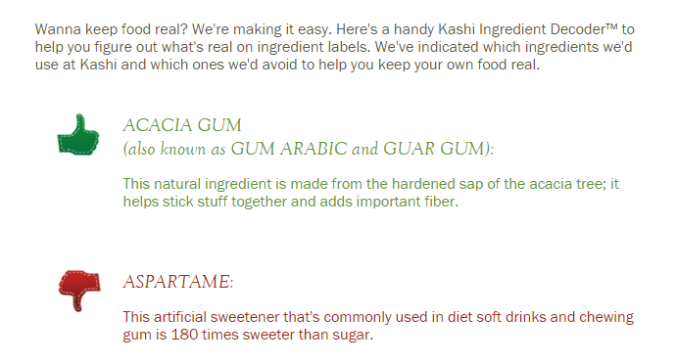

The FDA has stated that a product is not natural if it contains synthetic or artificial ingredients, but it has so far declined to create a detailed definition of natural; it has recently opened an inquiry into whether it should do so.

Federal regulations say that a synthetic substance is “[a] substance that is formulated or manufactured by a chemical process or by a process that chemically changes a substance extracted from naturally occurring plant, animal, or mineral sources, except that such term shall not apply to substances created by naturally occurring biological processes.” Also, an ingredient is artificial if it “is not derived from a spice, fruit or fruit juice, vegetable or vegetable juice, edible yeast, herb, bark, bud, root, leaf or similar plant material, meat, fish, poultry, eggs, dairy products, or fermentation products thereof.”

For meat, the USDA defines a “natural” product as a product that does not contain any artificial or synthetic ingredient and does not contain any ingredient that is more than “minimally processed”:

Minimal processing may include: (a) those traditional processes used to make food edible or to preserve it or to make it safe for human consumption, e.g., smoking, roasting, freezing, drying, and fermenting, or (b) those physical processes which do not fundamentally alter the raw product and/or which only separate a whole, intact food into component parts, e.g., grinding meat, separating eggs into albumen and yolk, and pressing fruits to produce juices. Relatively severe processes, e.g., solvent extraction, acid hydrolysis, and chemical bleaching would clearly be considered more than minimal processing. . . .

The USDA does not have authority to regulate non-meat products.

Kashi itself uses the following definition of “natural” on its website:
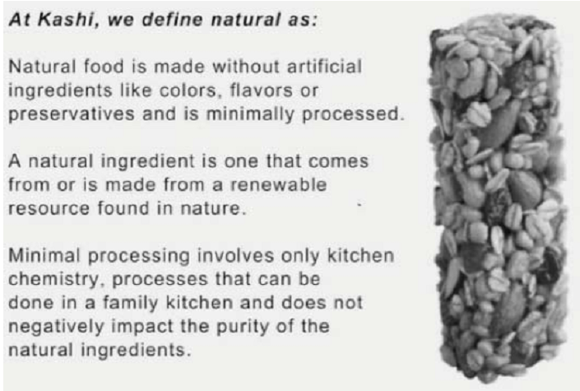

Kashi prominently displayed the promises “all natural” and “nothing artificial” on the front labels of almost all—but not all—of its products. However, Kashi’s “All Natural” GoLean Shakes have as significant ingredients such as sodium molybdate, phytonadione, sodium selenite, magnesium phosphate, niacinamide, calcium pantothenate, pyridoxine hydrochloride, thiamin hydrochloride, and potassium iodide.

The producers of the relevant ingredients began with plants, but extensively processed them in order to extract the chemicals/precursor chemicals. According to federal definitions, calcium pantothenate “is prepared synthetically from isobutyraldehyde and formaldehyde via 1,1-dimethyl-2-hydroxy-propionaldehyde and pantolactone.” Under federal regulations, magnesium phosphate can be prepared in one of two ways: by treating magnesium sulfate with disodium phosphate; or by treating magnesite with phosphoric acid, a s hazardous substance. Niacinamide “is the chemical 3-pyridinecarboxylic acid amide (nicotinamide).” It and thiamin hydrochloride are recognized as synthetic organic chemicals by the U.S. International Trade Commission. Potassium iodide is “prepared by reacting hydriodic acid (HI) with potassium bicarbonate.” Sodium molybdate has not been declared to be generally recognized as safe by the FDA. Sodium selenite has not been declared generally recognized as safe as a food additive by the FDA, but it is approved for use as an animal feed additive.

In addition, the soy protein in Kashi shakes comes from genetically modified soybean plants. A Technical Advisory Panel addressing the requirements of the Organic Foods Production Act of 1990 concluded that it was a synthetic substance for purposes of the organic food regulations.
Ichabod Crane, a purchaser and resident of California, sues Kashi under California’s consumer protection laws (the False Advertising Law, the Unfair Competition Law, and the Consumer Legal Remedies Act, though you need not consider each one separately) on behalf of a California class of purchasers of the product, alleging that the All Natural/nothing artificial claims are false and misleading. Identify the key issues and suggest how they should be resolved.

Kashi may seek to introduce evidence about the reasonable consumer, as Maybelline did.
Kashi products are similar to make-up in that they are easily purchased again and there
many possible competitors for dissatisfied customers to test out. However, unlike makeup,
which makes claims that the consumer herself can verify after use, Kashi's claims
about naturalness are not readily verifiable by the consumer. This fact may tell in favor of
regulation of the claims by the courts if they're misleading or false. In addition, there is
probably no presumption about the sophistication of the average Kashi consumer, as
there was in Gomez-Jimenez. Buying granola bars and going into deep debt for a law
degree are different sorts of decisions that consumers can be expected to take on with
different levels of research and fear. If there is no common meaning taken away by consumers, it may be difficult to get the class certified (in re Vioxx).
False or Misleading
Whether considered under FDA or USDA guidance or Kashi's own definitions, it seems
that at least some of their product advertising is explicitly false. While Kashi may try to
argue that "natural" is mere puffery because it is vague and has many meanings, as some
have argued with green or organic marketing claims (Seventh Generation, but see Tom's
of Maine). The fact that Kashi itself has attempted to define natural, and does so in a
pretty precise and verifiable way, should undercut a puffery defense. Additionally, in
Gerber, the fact that the FDA regulated "healthy" when used for food meant that it could
not be used as puffery. Under FDA definitions, all we know so far is that synthetic and
artificial ingredients are not natural. Magnesium phosphate, calcium pantothenate,
niacinamide, and thiamin hydrochloride are all synthetic under FDA regulations. On
those grounds alone, some of their products that are labeled natural are not natural under
FDA rules. These ingredients would also not fall under the FDA definition of artificial.
Under Kashi's own definitions, those same ingredients are not "from or ... made from a
renewable resource found in nature." To be 100% honest, I'm a little lost with the
chemistry elements of the question (which may be relevant in its own right insofar as I'm
at least a reasonable, if not sophisticated, consumer). But being charitable to Kashi and in
deference to my ignorance, suppose that Kashi can make out a claim that their products
do fit under their own definitions, so they are not literally false. Even then, Crane should
have a good misleadingness claim because no reasonable consumer would look at the list of chemicals in Kashi products and think they were "natural." Though study evidence
would be useful on this point, it seems plausible that consumers think natural is like
something you could make in your own kitchen, an inference Kashi's definition
encourages. I don't think I could make thiamin hydrochloride in my kitchen even if I
were very committed to trying.
While Kashi may try to claim that their definitions of minimal processing, artificial,
synthetic, and natural should trump government regulations that may not apply to their
products, there may be good reason to apply the definitions if consumers have come to
rely on regulation of those terms, as they have in the case of organic advertising.
In addition, the overall thrust of their advertising campaign is misleading because they
hold themselves out as a natural food company with particular "values," who will also
help consumers make decisions about what real food is (with the Ingredient Decoder).
They want the consumer to come away with the general impression that Kashi is
trustworthy on the whole, and that their individual products are all-natural and real,
whatever that turns out to mean. Because they cultivate that imagine while knowing that
some of their products contain decidedly non-natural ingredients, their whole advertising
campaign is misleading.
Materiality and Injury
There is a presumption of materiality where deception is shown in California. Under
Kwikset, Crane can show that members of the class would not have bought Kashi products but for the representations made about the natural ingredients. Materiality under
these state laws uses an objective test by looking for evidence that the public is likely to
be deceived (Elations). Crane should do consumer surveys about what they think
"natural" means and whether they would be willing to pay more for natural products. The
Elations court seemed moved by evidence that consumers were willing to pay extra for
the "clinically-proven" ingredients in that case, which seems analogous to this case and
distinguishable from Maybelline, where the evidence about consumer expectations and
willingness to pay a premium were mixed.
Following FTC views on materiality, anything that makes a difference to consumers can
be material (Kraft). While more evidence is needed in this case, naturalness does seem
like something that might make a difference to consumers, and reasonably so. While
there may be nothing about a naturally-occurring substance compared to one made in a
lab, those kinds of things matter to lots of consumers who may have all sorts of reasons
for wanting to avoid certain ingredients or processes, as shown by all the disputes over
bovine growth hormones in milk. That consumer desire to know may be enough to
generate materiality, particularly since there is no mandatory disclosure requirement
sought that would run afoul of the 1A, as there was in the Vermont case.
Class Issues
One of the biggest problems Crane may face is getting class certification in California.
Particularly because actual injury is required, Kashi may argue that a class cannot include
uninjured members because it then becomes unascertainable and difficult for the court to administer (Maybelline). However, Crane can take particular care to convince the court
that the class does contain only injured members to get beyond this requirement. Ideally,
each class member would have documentation of their purchase, but the court should be
willing to look beyond this for small ticket items. The Elations court was much more
willing to find the class there ascertainable, noting that acceptance of defendants
arguments would render the class action useless. There the court accepted affidavits
asserting that members had purchased the product, which may be sufficient in this case.
23a certification
It should not be difficult to meet the numerosity and adequacy requirements assuming
that Crane's class includes more than 40 or so people and his legal team is somewhat
experienced. It may be difficult to get commonality, however, because he will need to
show that all class members suffered the same actual injury under the law. If there is one
common question of law or fact, this should suffice to get commonality. In this case,
Crane may argue that the questions of fact relating to the advertising campaign and the
questions of law as to the harm of Kashi's statements are enough. If the court is skeptical,
as in Maybelline, however, they may accept an argument from Kashi that there was no
common expectation associated with the natural claim. However, the Elations court was
more giving on the commonality inquiry, noting that the existence of the purportedly
misleading claims on the packaging was enough to generate common questions of law
and fact. The instant case is similar in that regard, since some of the naturalness claims
were on the packaging. However, Crane should consider setting up sub-classes of people
who also visited the website and saw the ingredient decoder and definitions of natural, in
case the questions of fact diverge for the groups.

"Genetically Modified"
The inclusion of genetically modified soybeans may be properly considered "natural".
While it is a synthetic substance for purposes of organic food regulations, Kashi has not a
claim that its ingredients are organic. It is quite possible than a GMO ingredient may
nonetheless be considered natural if it is not subsequently subject to extensive chemical
processing. Thus unless there is survey evidence that consumers believe "All Natural"
foods should also not contained genetically modified ingredients, there may not be a
problem with calling soybeans natural. But this sliver of truth will not save Kashi when
all the other aforementioned ingredients do make the "All Natural" usage false.

END OF EXAM

