INSTRUCTIONS:

- This is an OPEN book midterm. You may consult any inanimate object; however, no credit will be given for citations to any materials that were not assigned for this course. You may not discuss the content of this midterm with any other person, whether or not that person is enrolled in this class.

- Although the questions are based on real situations, I have changed the facts in ways subtle and not-so-subtle, so you could really do yourself more harm than good by looking for outside information on the fact patterns.

- This midterm must be submitted through TWEN. You may work on the midterm throughout the midterm period. Please use your last name as the beginning of the filename.

- Structure: There are 2 questions worth 15 points each. You should allocate your effort accordingly.

- For each individual question, the maximum word count for the answer is 1000 words. I do not expect each answer to require that many words. Please think, organize, and prioritize carefully before you write. Cogent, well-structured answers that devote the most analysis to the most important issues will be graded more highly; poorly-organized, ungrammatical, or chronically misspelled answers will receive lower grades. If you need additional facts to answer a question, please state the specific facts needed and how they would affect your analysis. Also, please don’t call a person “he” if she’s clearly identified in the facts as female. I reserve the right to deduct points if you do.

- This midterm is final. There will be no clarifications or changes. If you believe there is an error, inconsistency, or omission in the exam, please state your assumptions about the issue within your discussion of that issue.

- Citation to relevant materials is required in order to receive full credit. Please indicate why the cited materials are relevant. You do not need to use Bluebook form. For example, simply state: (FTC v. Kraft) or (§43(a)). You can use italics, bold, or whatever you’re most comfortable with to indicate case names.

Question 1: Hyatt

This is a picture from the newly revised front page for the website of the Hyatt across the street:
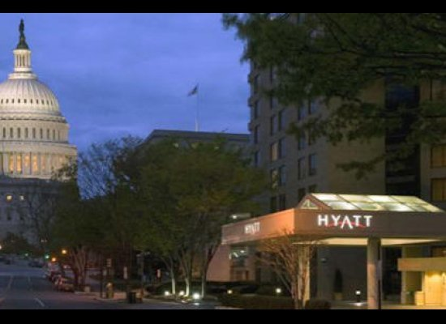

This photo was taken with a zoom lens. Alongside the photo, the website claims “Unparalleled access! You’ll be minutes from the Capitol and other key Washington attractions.” Visitors can click for further information on room rates, but the photo and text are the key portions of the webpage. In addition, the Hyatt plans to run ads in various national publications featuring the same photo and text, with contact information that will allow consumers to make reservations.

Here is a photo of the same view taken with a standard lens:


The Hyatt is .4 miles from the US Capitol as the crow flies. Given the rate at which most tourist groups walk and the enhanced security around the Capitol, most groups could expect to reach a tourist entrance to the Capitol in 25-30 minutes. (Because of that enhanced security, taxis would be no faster, though someone could reach, but not enter, the security perimeter of the Capitol using a Segway in under 10 minutes.)

There are three small-capacity, high-end hotels that are several hundred yards (and thus several minutes by foot) nearer to the Capitol than the Hyatt is, but none offer rooms for as low as $360 a night, as the Hyatt does.

When questioned about the “unparalleled access” claim, the manager explained that, when guests check in, they’re told that the Hyatt offers a concierge service for an extra fee of $60 a day (plus any ticket and service costs charged by venues) that secures tickets to various Washington attractions that require tickets, such as the Butterfly Garden in the Natural History Museum, special exhibits at the various art galleries, and tours of the Holocaust Museum. While some other hotels in the area provide this service on a case-by-case basis, the Hyatt is the only one that routinely stocks all sorts of tickets so that they are readily on hand whenever a patron asks.

1) List the claims you think the ad makes.
2) Classify those claims as puffery/opinion or fact and explain why.
3) For the claims you think are facts, give examples of evidence you think would adequately substantiate the claim. If you think the claim should be revised, explain why and how you might suggest to revise it.

Question 2: Surcharges

The state of Disturbia’s No Credit Surcharge law that provides: “No seller in any sales transaction may impose a surcharge on a holder who elects to use a credit card in lieu of payment by cash, check, or similar means. Where no price for a good or service is more prominent than an advertised price for that good or service, that advertised price shall not be deemed to include a surcharge.” The result of the law is that sellers cannot advertise a price, then state that they impose a surcharge for credit. However, they can (1) advertise a price and then state that they offer a discount for cash, or (2) advertise two prices, one for cash and one for credit, as long as the two prices are equally prominent. Advertising the cash price and then a percentage surcharge for credit is not allowed, nor is advertising the cash price more prominently than the credit price.

The background is as follows: Credit card companies charge processing fees to the merchants who accept credit card transactions, usually around 2-3% of the total transaction (with a required minimum that can mean that the percentage charged for small purchases is an order of magnitude higher). Given these extra costs, merchants would prefer to charge extra for credit purchases. However, consumers react very differently to the term “surcharges” for credit compared to the term “discounts” for cash, even though the two ought to be economically identical given identical prices for credit purchases. Consumers resist paying “surcharges,” and thus use credit less often when that label is used, while they rarely take advantage of “discounts” for cash. Essentially, consumers perceive credit-card surcharges negatively as a kind of loss or penalty, while cash discounts are perceived positively as a kind of gain or bonus.

Many businesses therefore don’t bother to offer “discounts” for cash and thus just charge higher prices to everyone. The resulting yearly subsidy from cash-using households to credit-users (who tend to be whiter and richer than cash-users) has been estimated at $149, with $1333 transferred to each card user. The prices charged to merchants by credit card companies are among the largest and fastest-growing expenses for some merchants.

Before the law was enacted, some consumers complained to regulators that they’d been lured in by advertised prices and only at the point of purchase, when they’d already finished their shopping, informed of a surcharge for credit. Regulators were also concerned by evidence that more than 2/3rds of consumers regularly had trouble calculating percentages. However, the state has not put similar blanket constraints on taxes, shipping fees, installation fees, and other charges—all of which are routinely added at the time of purchase. Taxes are routinely disclosed as percentages. Disturbia has a general unfair trade practices law that bans false and misleading advertising, and regulators have occasionally used it to enjoin individual advertisers’ “hidden” fees or charges when consumers were actually misled by them.

Molly Merchant, a salon owner who wishes to call attention to the processing fees charged by credit card companies by advertising her cash price and stating that she charges 5% extra for using credit, challenges the No Credit Surcharge law under the First Amendment. Identify the parties’ arguments and explain who should prevail.

