INSTRUCTIONS:

- This is an OPEN book midterm. You may consult any inanimate object; however, no credit will be given for citations to any materials that were not assigned for this course. You may not discuss the content of this midterm with any other person, whether or not that person is enrolled in this class.

- Although the questions are based on real situations, I have changed the facts in ways subtle and not-so-subtle, so you could really do yourself more harm than good by looking for outside information on the fact patterns.

- This midterm must be submitted through TWEN. You may work on the midterm throughout the midterm period. Please use your last name as the beginning of the filename.

- Structure: There are 3 questions worth 10 points each. You should allocate your effort accordingly.

- For each individual question, the maximum word count for the answer is 600 words. I do not expect each answer to require that many words. Please think, organize, and prioritize carefully before you write. Cogent, well-structured answers that devote the most analysis to the most important issues will be graded more highly; poorly-organized, ungrammatical, or chronically misspelled answers will receive lower grades. If you need additional facts to answer a question, please state the specific facts needed and how they would affect your analysis. Also, please don’t call a person “he” if she’s clearly identified in the facts as female. I reserve the right to deduct points if you do.

- This midterm is final. There will be no clarifications or changes. If you believe there is an error, inconsistency, or omission in the exam, please state your assumptions about the issue within your discussion of that issue.

- Citation to relevant materials is required in order to receive full credit. Please indicate why the cited materials are relevant. You do not need to use Bluebook form. For example, simply state: (Wal-Mart) or (§2(d)). You can use italics, bold, or whatever you’re most comfortable with to indicate case names.

Question 1: The Family Business

On May 2, 1997, Dean Winchester filed an ITU application for THE FAMILY BUSINESS EXTERMINATORS (“EXTERMINATORS” disclaimed) for pest control services. The application was allowed in early 1998, and Winchester timely filed a statement of use. Winchester operated The Family Business exterminators in Kansas from late 1997 to the present day. In 2004, the registration was cancelled for failure to file a renewal affidavit. Winchester has spent between $10,000 and $50,000 per year in advertising to the Kansas market, including radio ads, local television ads, and internet keyword ads displayed to people who search Google for “kansas exterminator” or who search “exterminator” and whose IP (internet protocol) address indicates a Kansas location. His sales have gradually increased to over $12 million per year.

In early 2003, Charlie Bradbury, who had no actual knowledge of Winchester’s mark, opened Bradbury’s Family Business Exterminators in Maryland. She advertised throughout Maryland, using means similar to Winchester’s. However, she mainly provided services only in Baltimore, Maryland, though she occasionally provided services in rural and suburban areas throughout Maryland. In January 2009, she licensed franchises in Chevy Chase, Maryland and Norfolk, Virginia based on her strong sales in the Baltimore area.

On January 24, 2007, Winchester filed a new application to register FAMILY BUSINESS EXTERMINATORS, claiming a first use date of May 2, 1997. The registration duly issued in late 2007. In 2008, he signed a nationwide licensing deal with Lafitte Enterprises, a furnace/air conditioning repair company looking to expand its operations to extermination services. The new service was branded Lafitte Family Business Exterminators, and it became available throughout the Western half of the United States in November 2008. At that time, Lafitte informed all its existing customers of its new service and also spent over $1 million in TV, radio, and internet advertising.

In December 2008, Lafitte discovered Bradbury’s website for her extermination service, bradburyfamilybusiness.com, and sent a cease and desist letter. Bradbury responded with a claim that she had the right to use the mark.

In March 2009, Lafitte expanded Lafitte Family Business Exterminators to the Eastern US, including Maryland, where it spent roughly $100,000 on advertising. In connection with its “grand opening” event in Maryland, two people called to ask if Lafitte’s service was related to Bradbury’s.

Identify the key legal issues and explain the parties’ rights.

Question 2: PABLO ESCOBAR

Pablo Escobar was a Colombian drug lord who ran a vast cocaine empire, ordered thousands of enemies killed, and became one of the wealthiest and most powerful men in the world in the 1980s. His victims included numerous law enforcement officers, government officials, and journalists, as well as drug rivals. The head of his squadron of hit men admitted killing at least 3,000 people for his boss, many through more than 100 bombs set off at schools, banks, hotels, telephone and electric companies.

Escobar’s exploits routinely drew front-page newspaper and network news coverage in the US in the 1980s through the time of his death. He was killed by the Colombian authorities in 1993. His life and death have been the subject of numerous books published in the US as well as two made-for-TV movies and a planned feature film. In addition, he is universally known in Colombia. There are roughly 1 million Colombian immigrants living in the US.

Damon Salvatore, a self-professed Escobar “fan,” has filed an application to register PABLO ESCOBAR for clothing. Below is the image he uses on the clothing tag (submitted as a specimen of use):



The shirts themselves feature images and text taken from Escobar’s criminal dossier with the Colombian government:
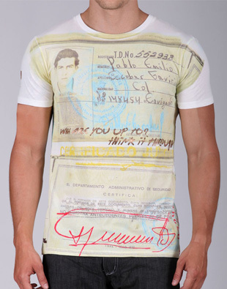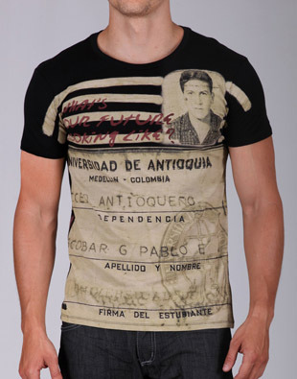

Identify the key issues with the application and how an examiner should resolve them.

Question 3: CAPITOL ROOFING

Capitol Roofing is a roofing business that operates only in suburban areas of Virginia and Maryland surrounding Washington, DC, and not in Washington, DC itself. “Capitol” means “a building in which government meets.” “Capital” has a distinct but related meaning of “the municipal seat of government” and also the meaning “excellent.” Capitol Roofing does not operate in either Virginia’s capital or Maryland’s capital. Capitol Roofing has been in business for 20 years, advertising through local media. It has received numerous reviews on local consumer websites, from Yelp to Angie’s List. Though numerous other Washington-area businesses use “Capitol” or “Capital” in their names, none of them are roofing companies.

The Washington Capitals are a moderately successful professional NHL hockey team, in existence since 1974. Their games are broadcast on local and national television; the team is valued at $250 million ($34 million attributable to the brand value, according to a Forbes analysis), with $106 million of revenue each year. The Washington Capitals have registered the following logo for entertainment services, namely hockey games and broadcasts, as well as for clothing, bumper stickers, mugs, and numerous other products:
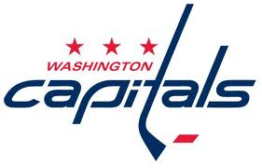
The Capitals sell roughly $30 million in merchandise (including T-shirts, caps, bumper stickers, and mugs) bearing this logo every year, mostly to local fans. The logo also appears every time a game is broadcast and in many news images of the team.

Capitol Roofing adopts a new logo and applies to register it for roofing services (CAPITOL, ROOFING, and USA disclaimed):
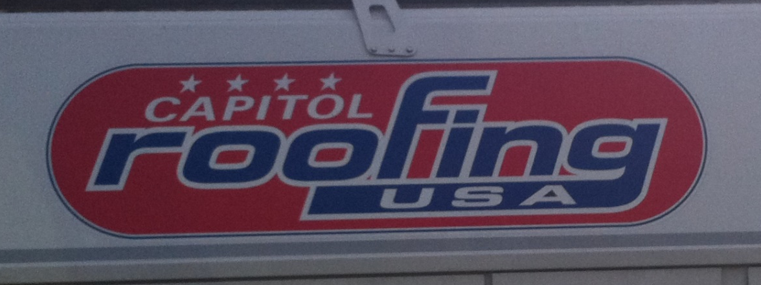

The application is published for opposition, and the Washington Capitals oppose.

Identify the arguments the Capitals should make and how the TTAB should resolve the issues.

